**Chapter – 4: Data Ingestion from Blob**

**Copy Activity**

Azure Blob Storage -> Azure Data Lake

Click on All resources and open Azure Blob Storage that created.

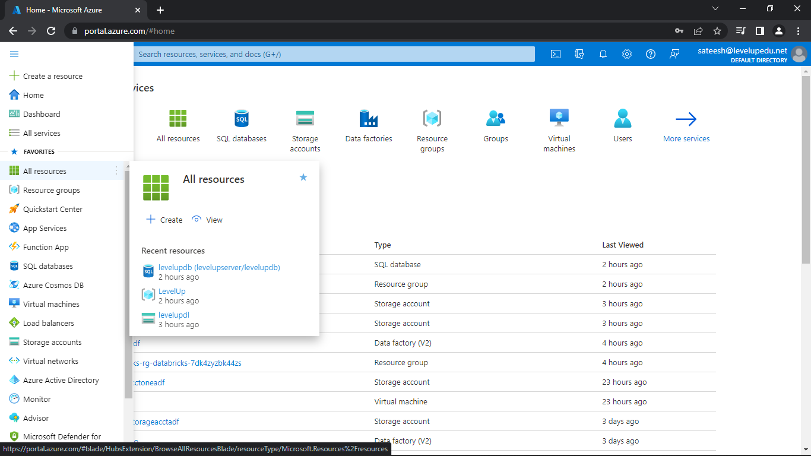

Now, go to the containers and create a container

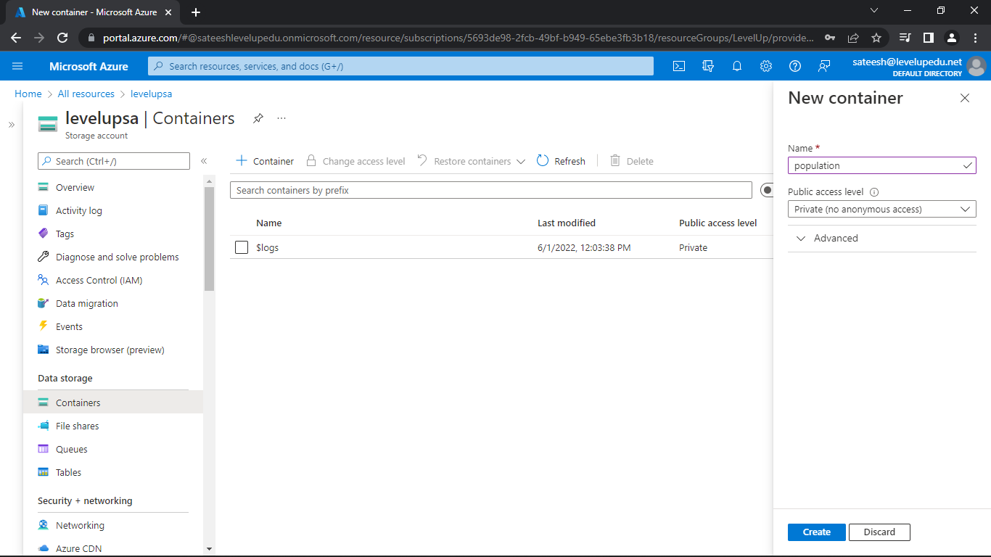

Open the container created and upload the file

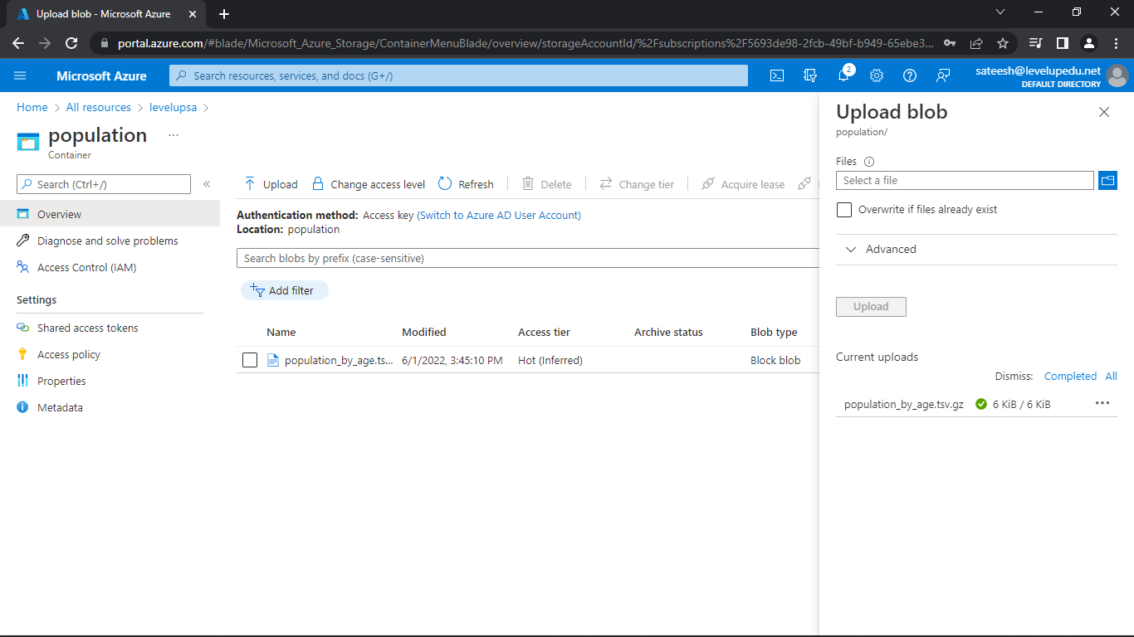

Click on All resources and open Azure Data Lake that created.

Now, go to the containers and create a container

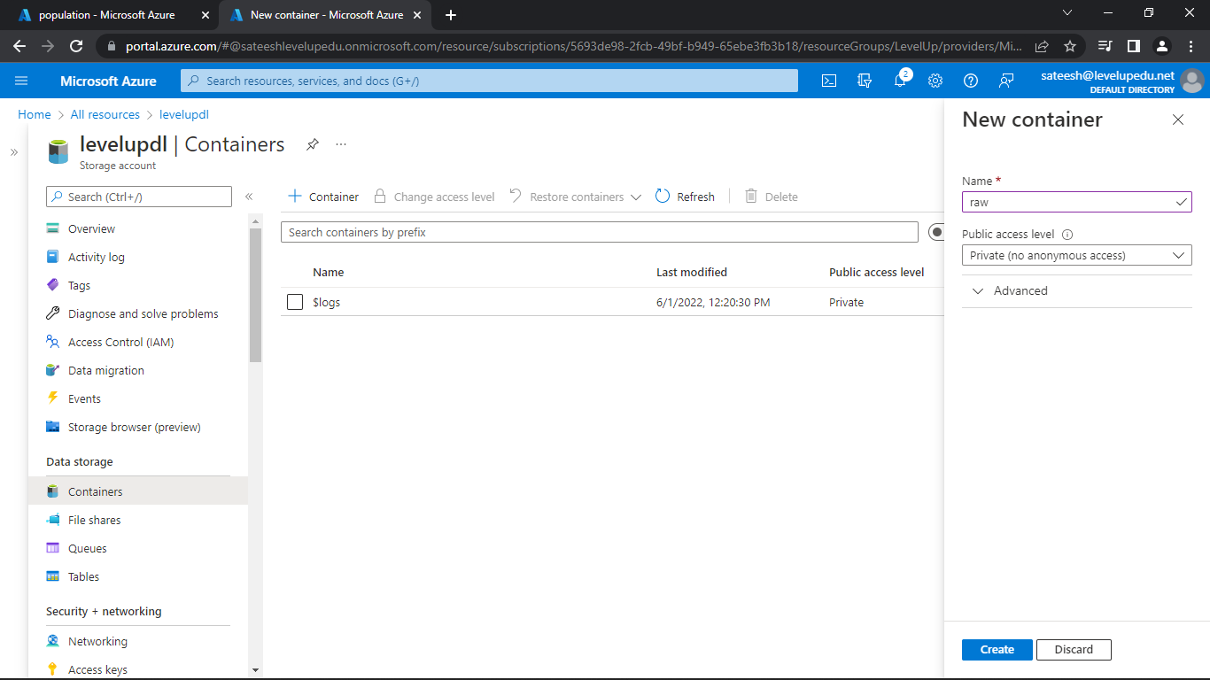

So, the two things are done to do with the storage accounts, with that, we've now prepared both storage accounts ready for the copy activity.

**Naming Standards – Slide 60**

**Linked Services and Data Sets**

Click on All resources and open Azure Data Factory that created.

Now, click on the Open Azure Data Factory and click on Manage.

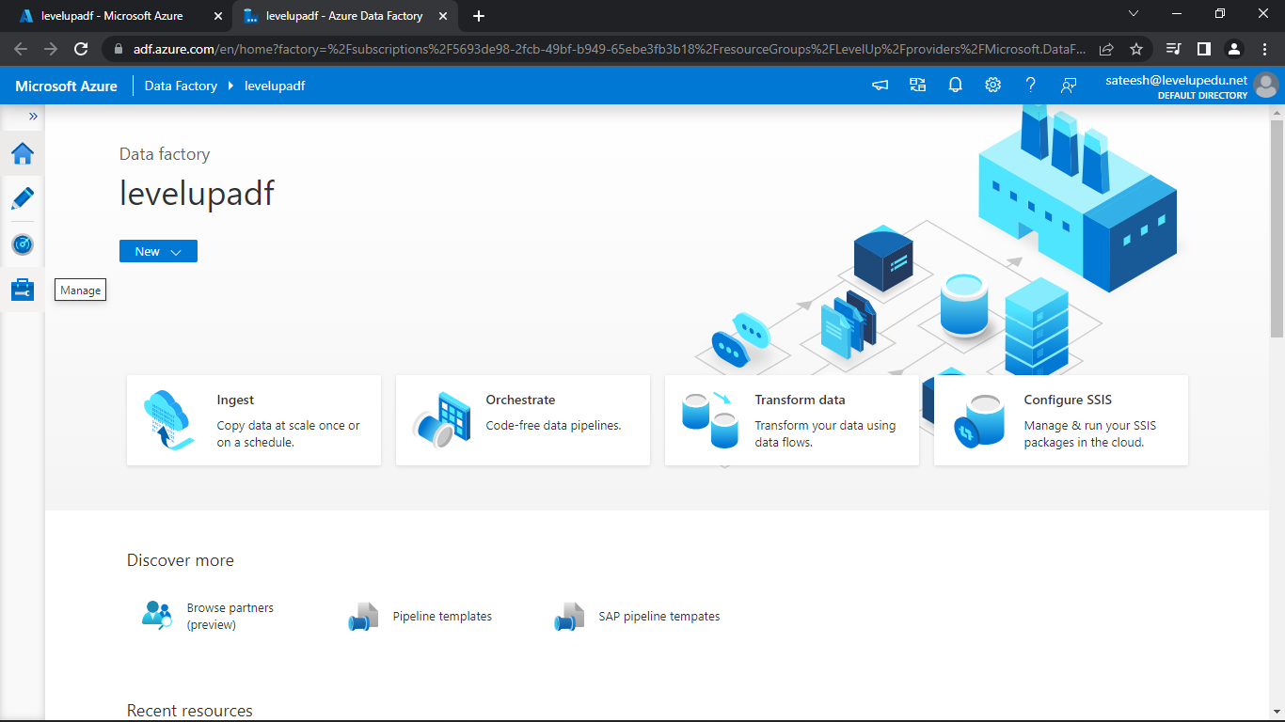

Select Linked Service and click on New and select Azure Blob Storage.

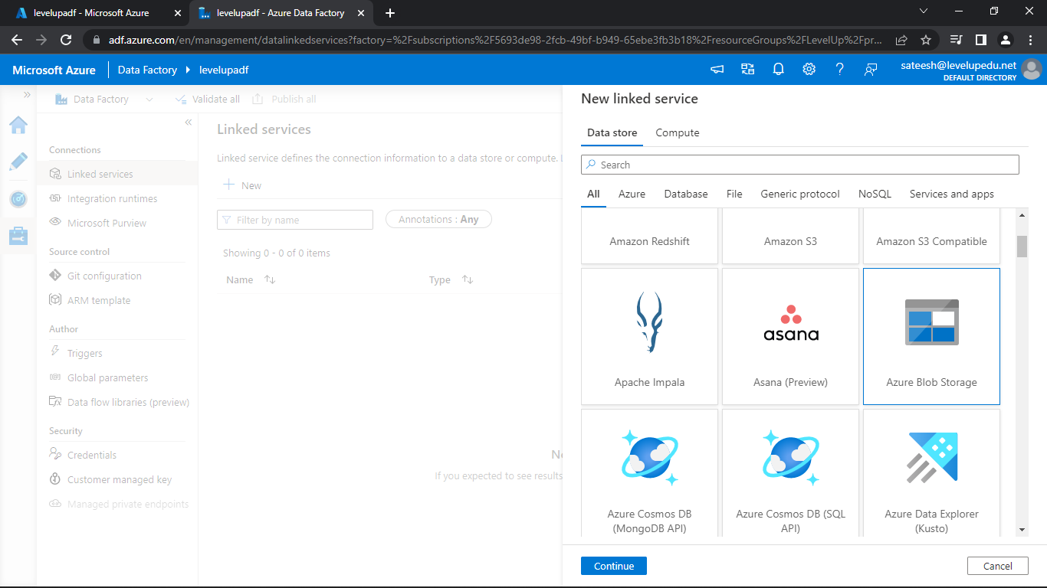

Fill the required details and test the connection

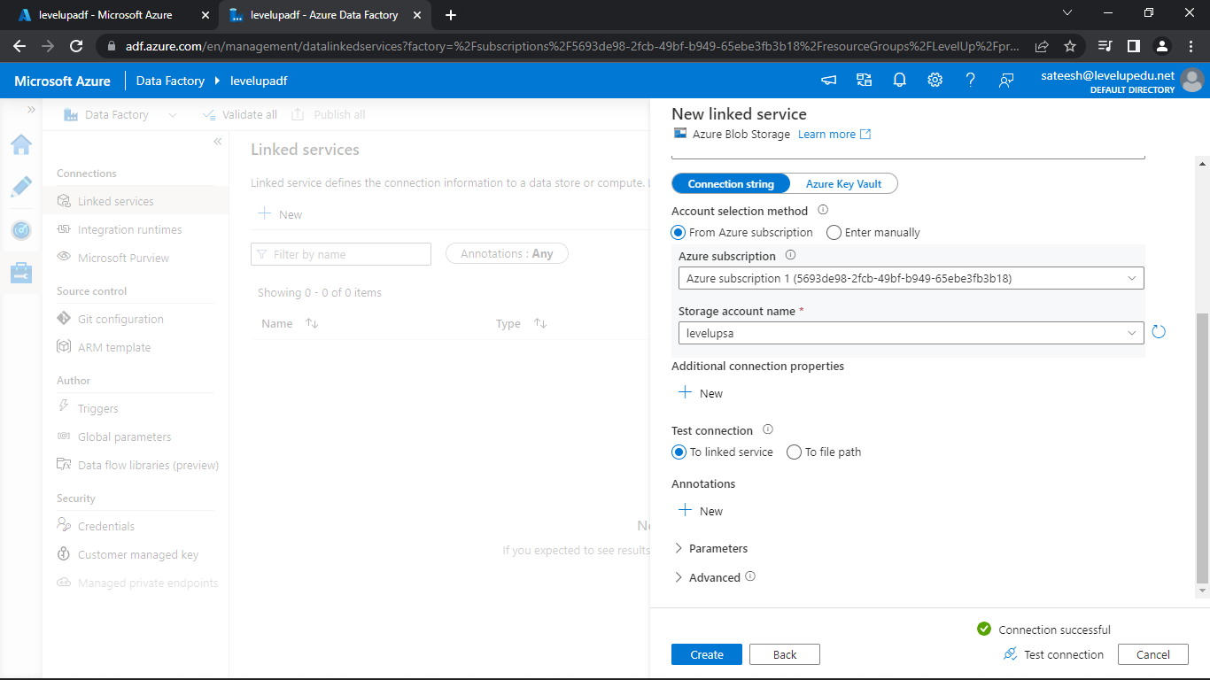

Click on Create. So, the linked service for Blob storage has been created.

Now, click on New and select Azure Data Lake Storage Gen2 and continue.

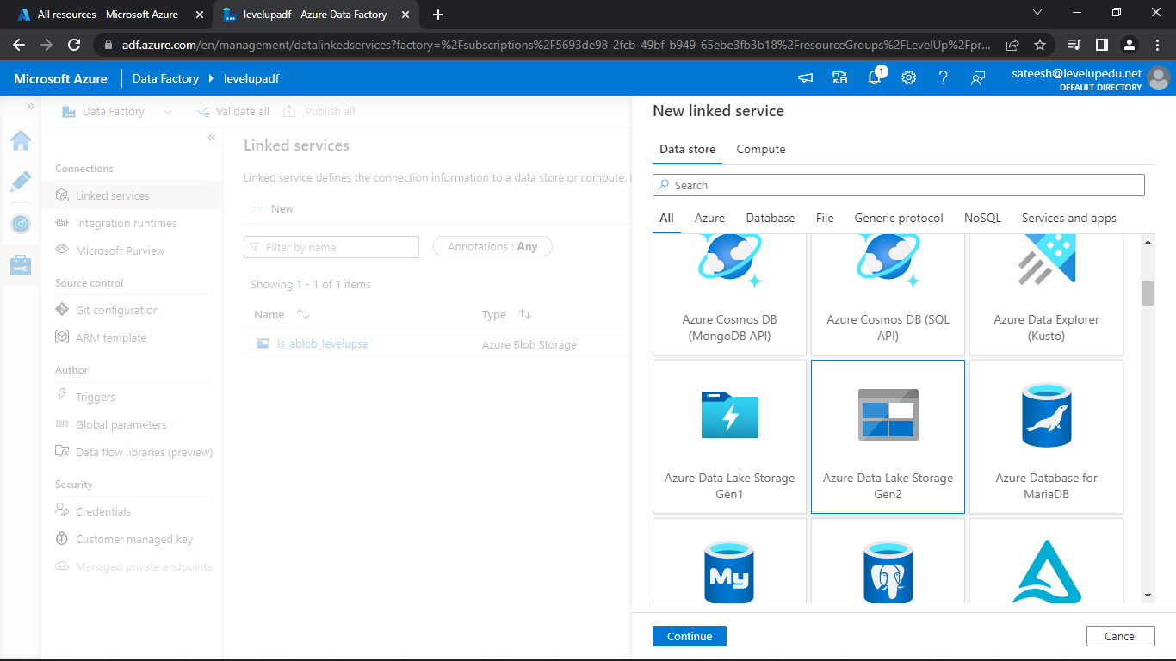

Now, Fill the required details and test the connection

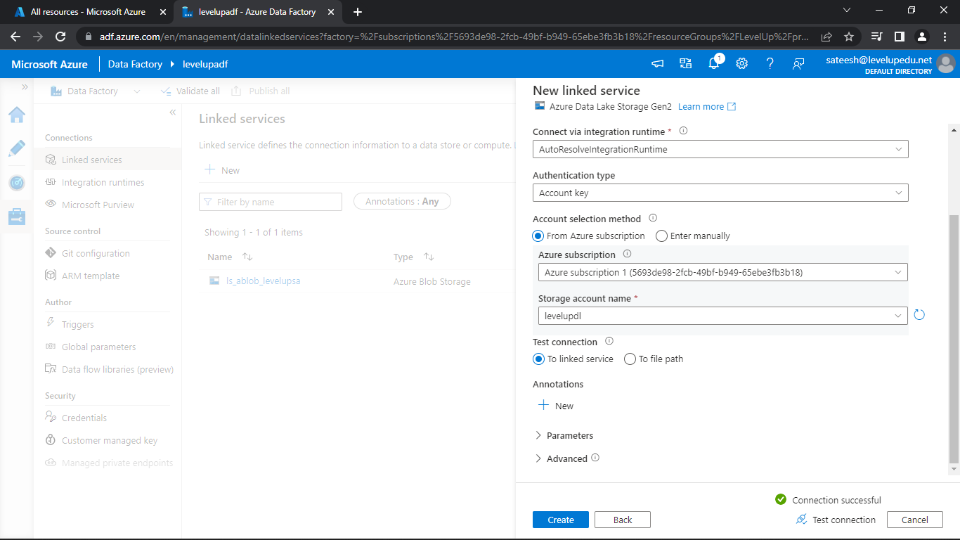

Click on Create. So, the linked service for Data Lake has been created.

Now, we must create a dataset so click on the pencil icon on left hand side and click on three dots on datasets and create a new dataset for Blob Storage.

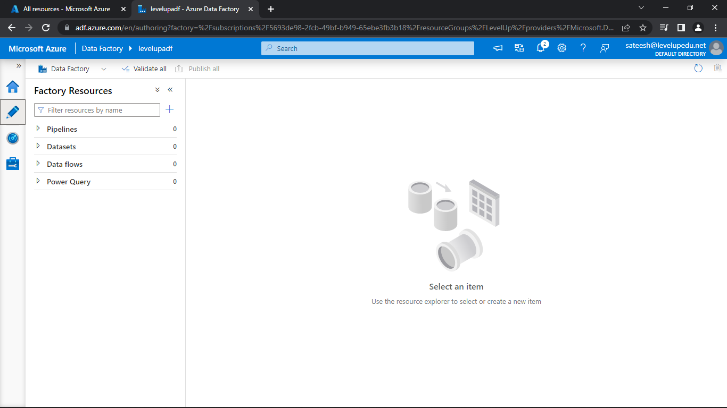

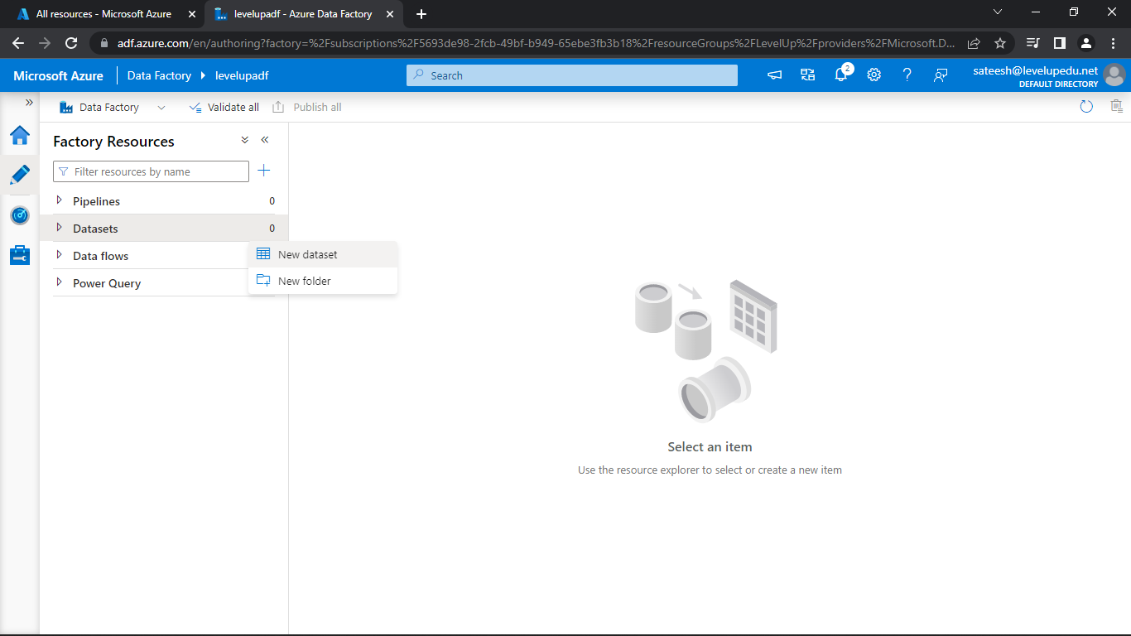

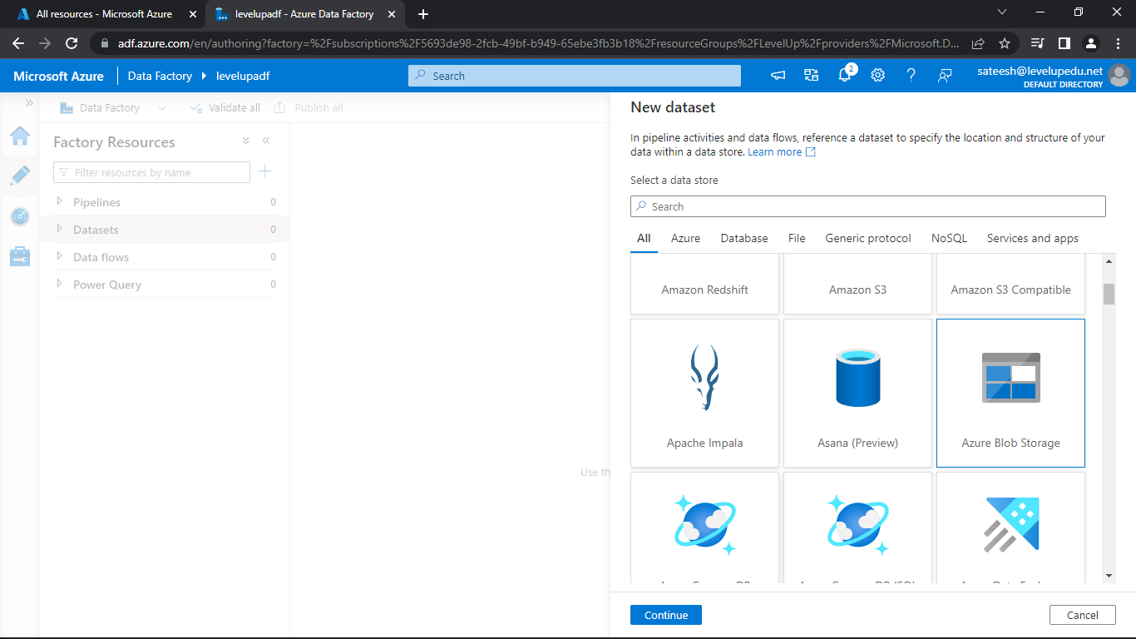

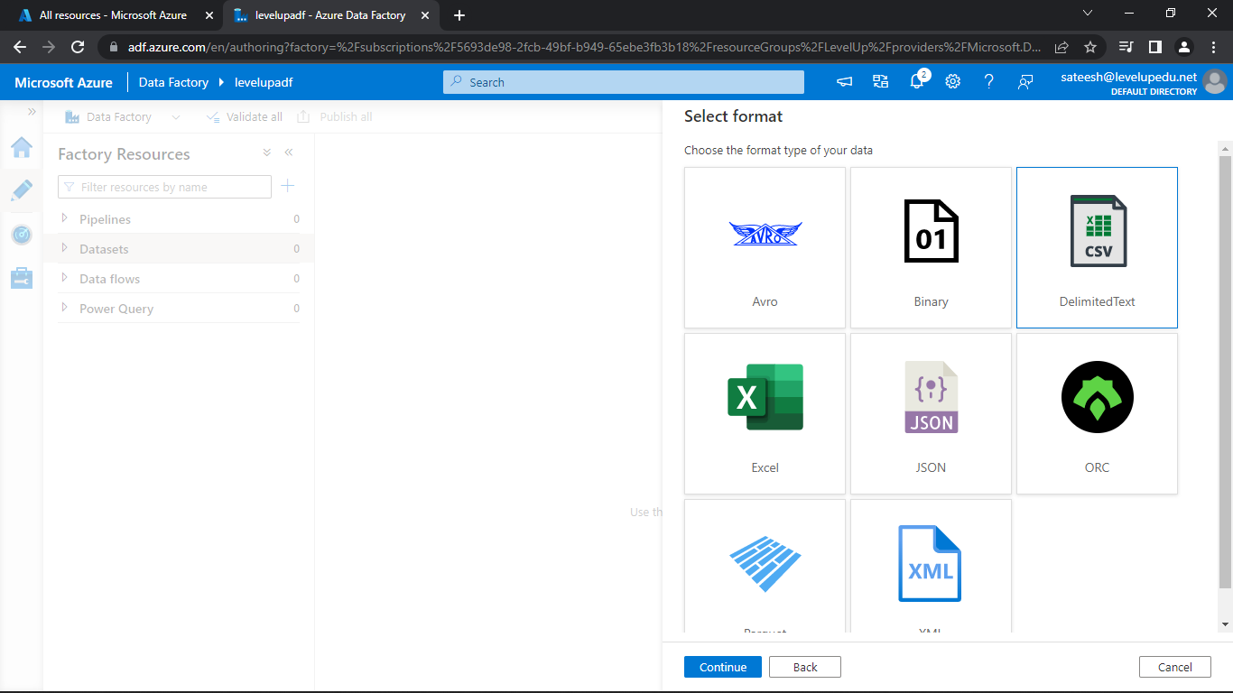

Now, fill the required details and upload the container name and file name and click OK.

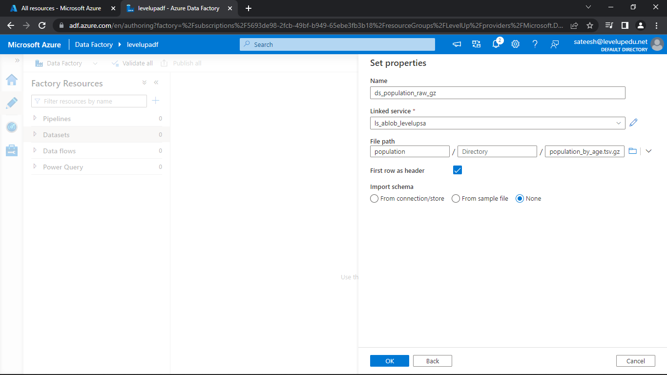

Now, select Compression type as gzip, Compression level as Optimal and Column delimiter as Tab.

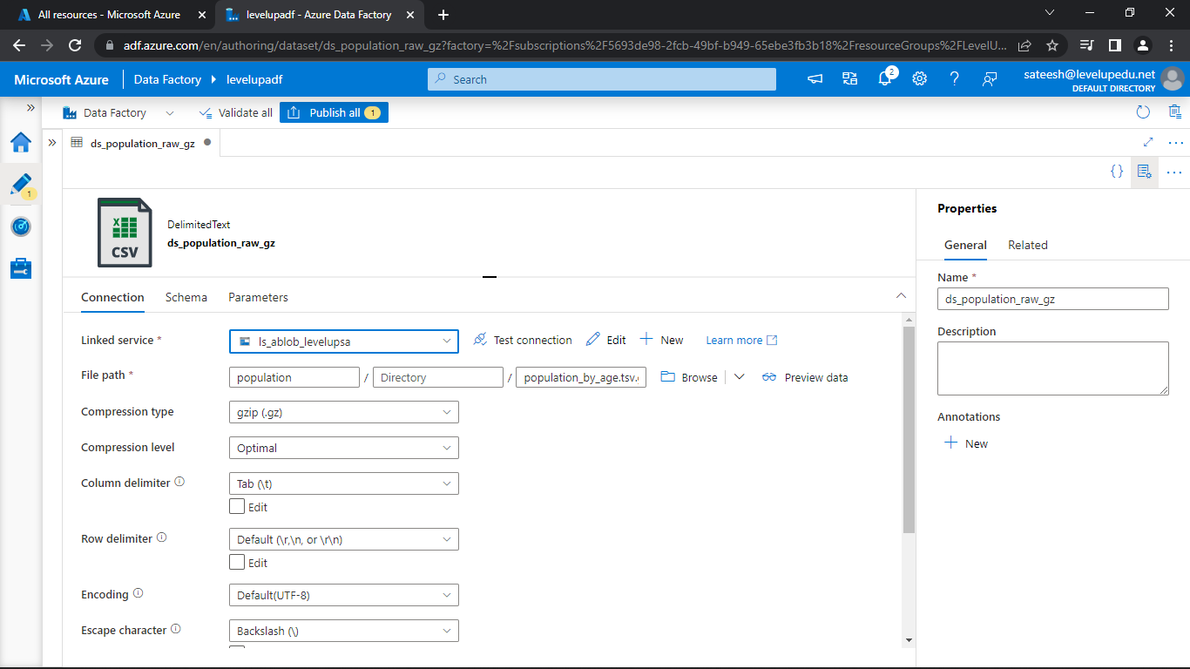

Now, create a new dataset for Azure Data Lake Storage

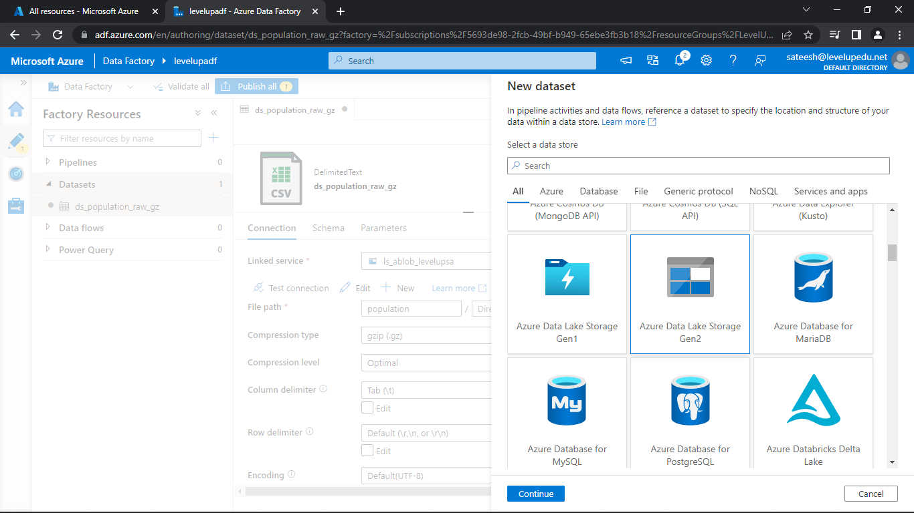

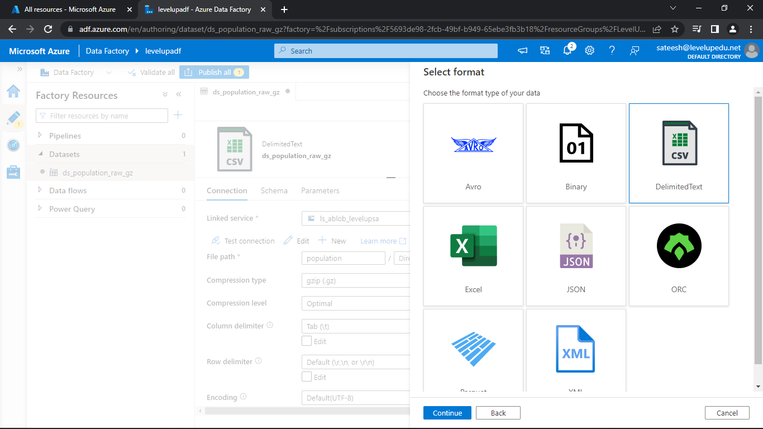

Now, fill the required details and upload the container name and file name and click OK.

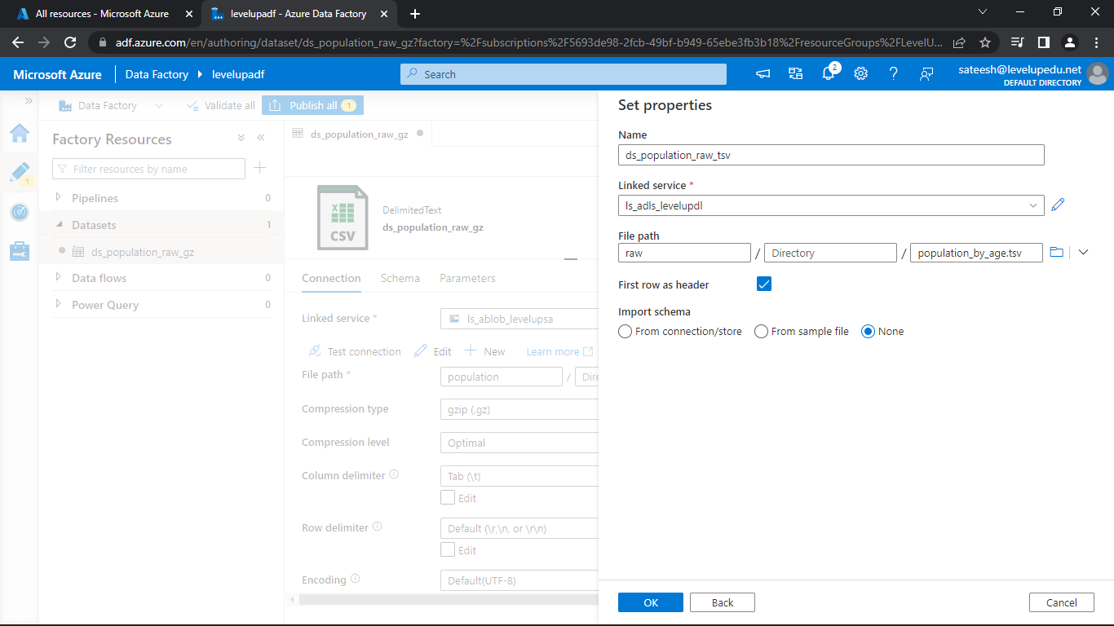

Now, Change the Column delimiter as Tab.

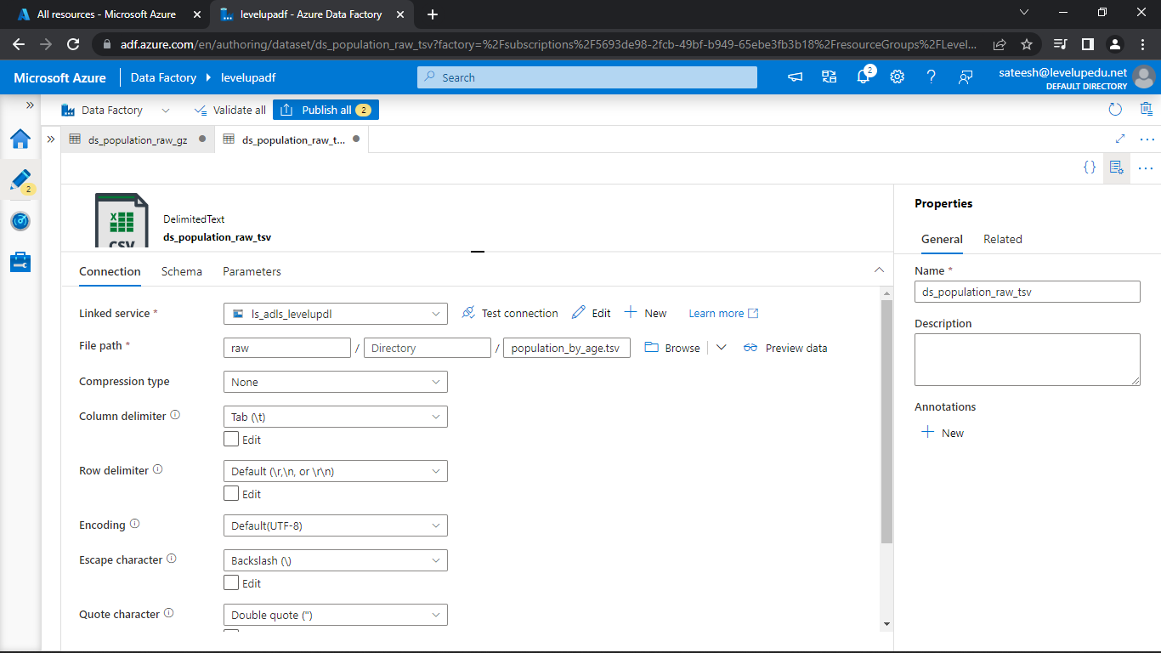

So, let's switch back to the Blob Storage source.

So, this one, we've already put the file in our container.

So, let's click on the preview.

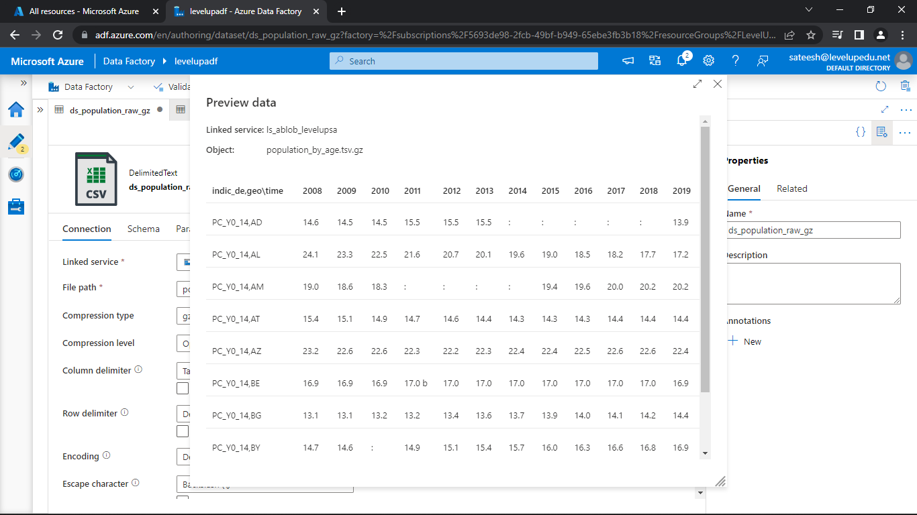

Click on Validate all and see if there are any errors.

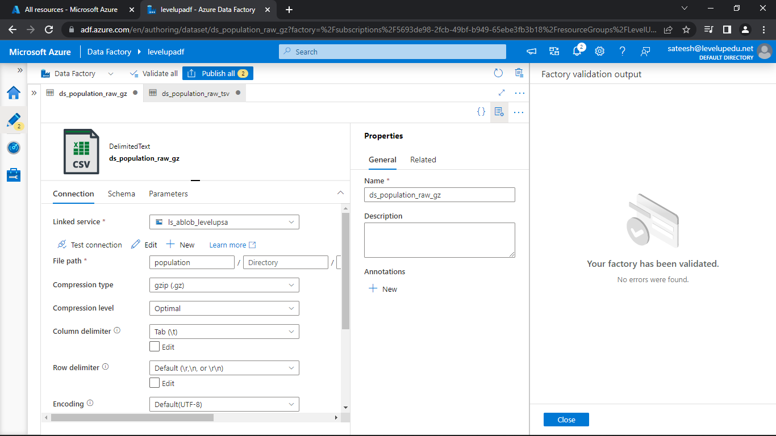

But anything you do within the art tab is not immediately saved within the data factory.

You can run debug.

So, you can do all of that while you are in there.

But if you come out of it, your work will not be saved.

So, click on Publish all and publish.

Now, the work will be saved.

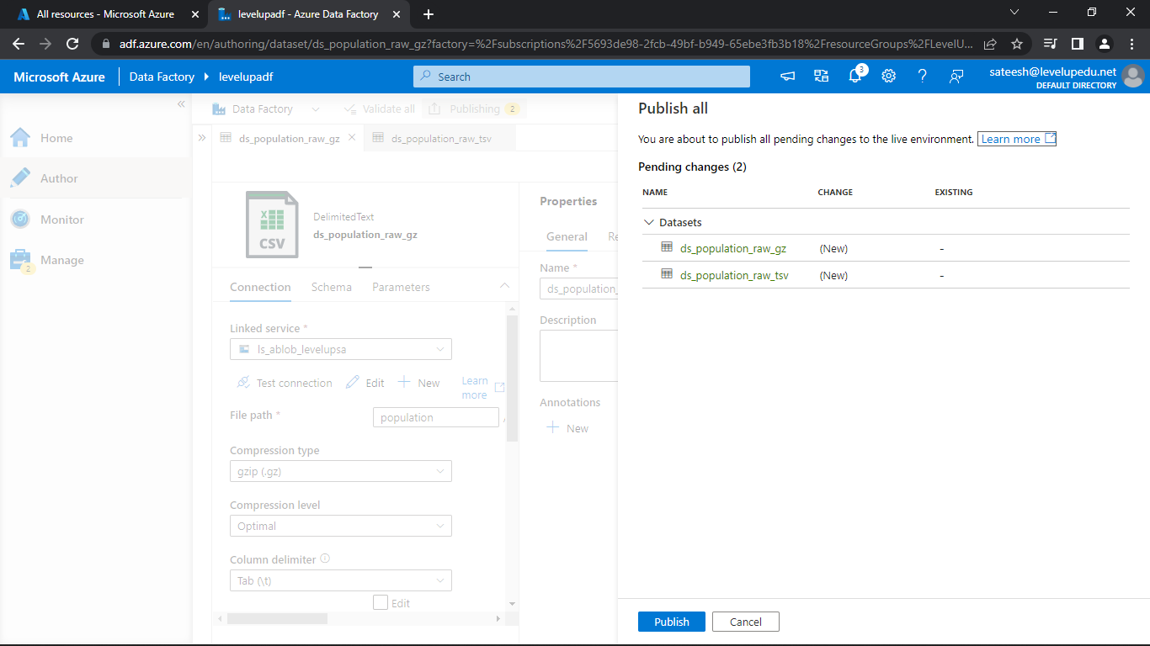

**Creating ADF Pipeline**

For creating a pipeline, click on three dots next to pipelines and select New pipeline.

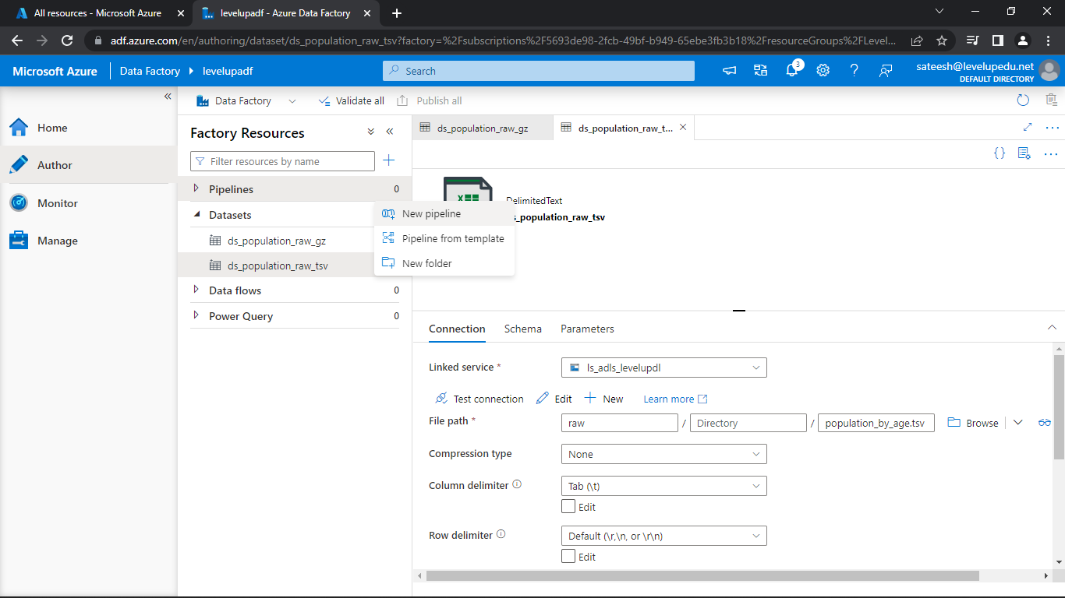

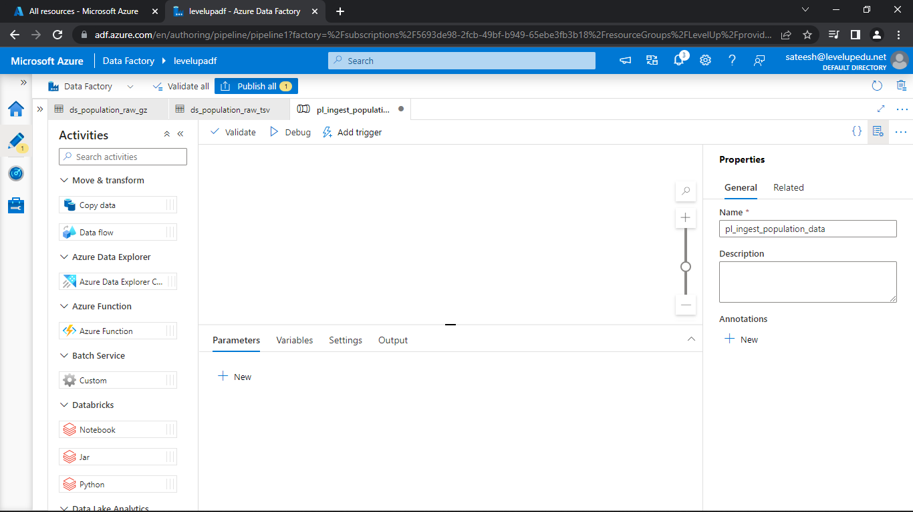

Change the name as required and pull the copy data activity into the pipeline pane.

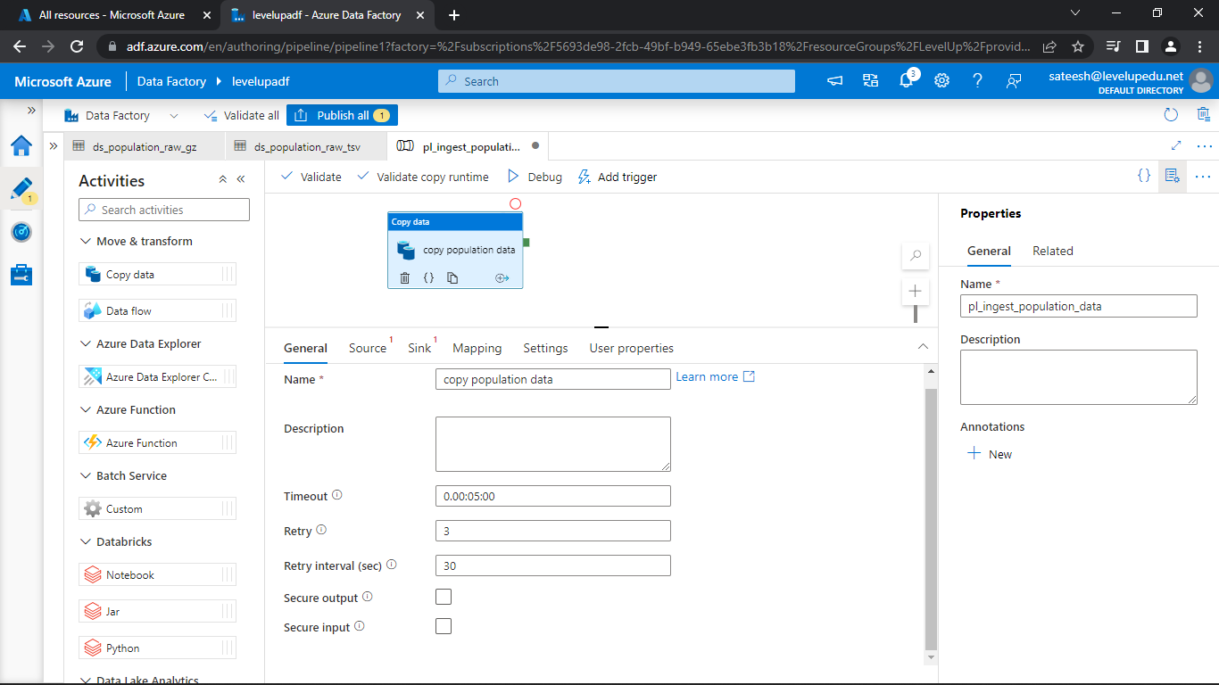

Change the name If required

Change the Timeout to 5min

Change Retry to 3

Change the Retry Interval to 30sec

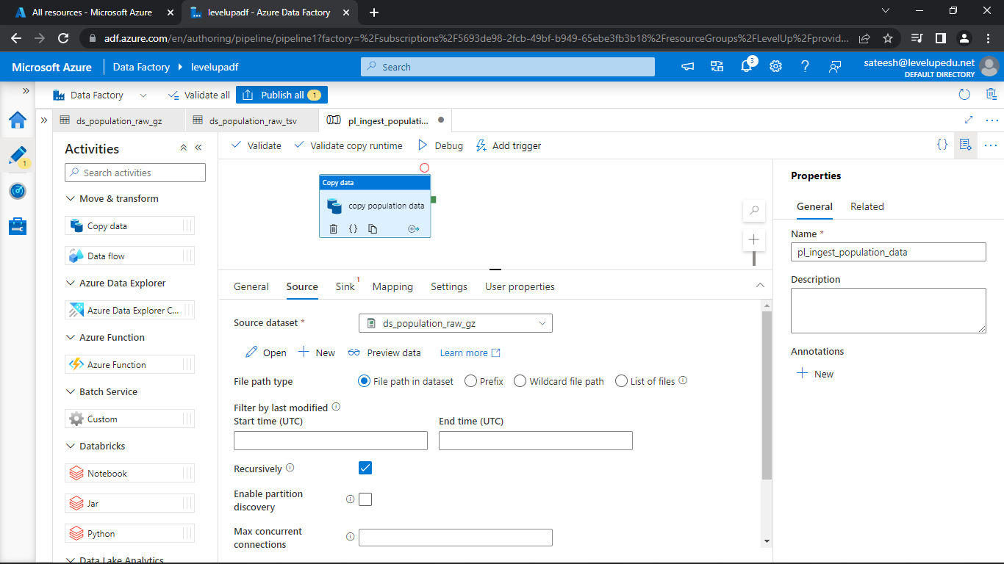

Select the Source dataset

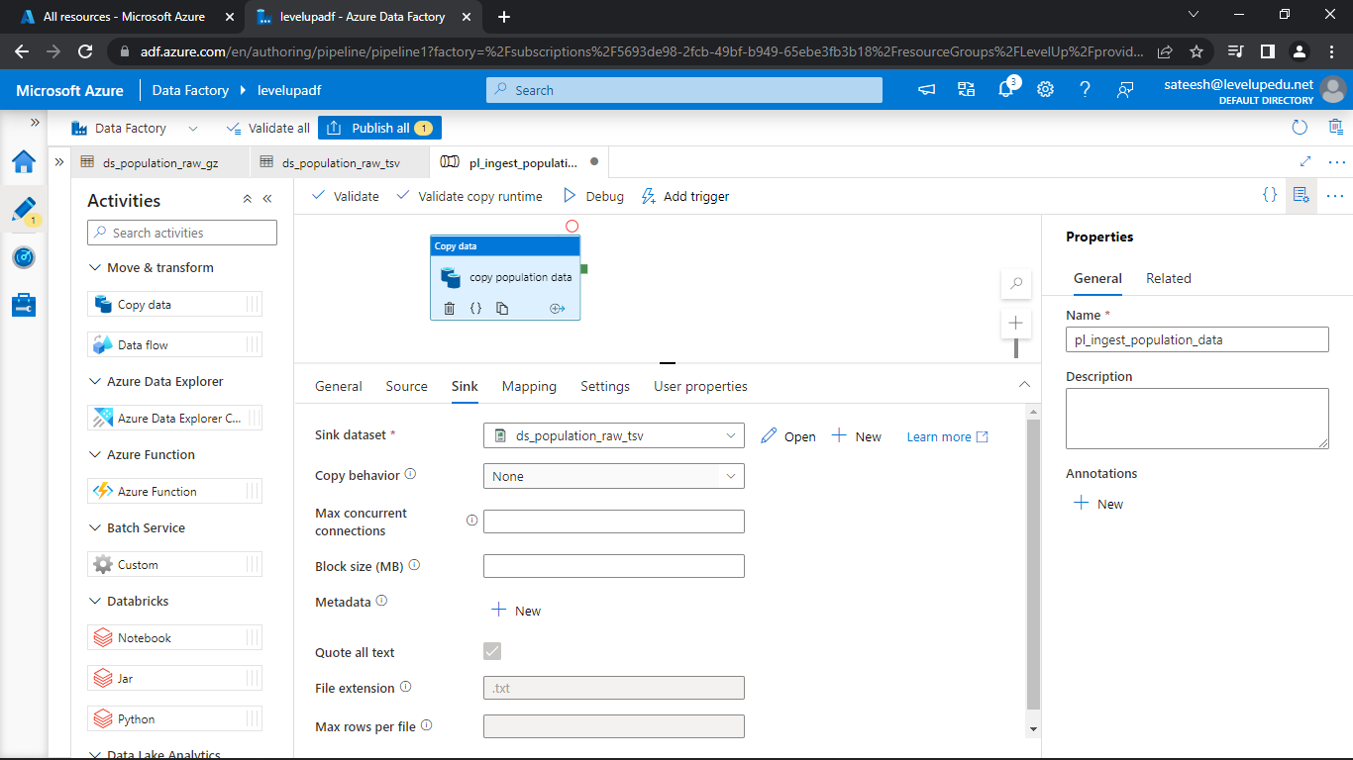

Select the sink dataset

Validate the pipeline for errors

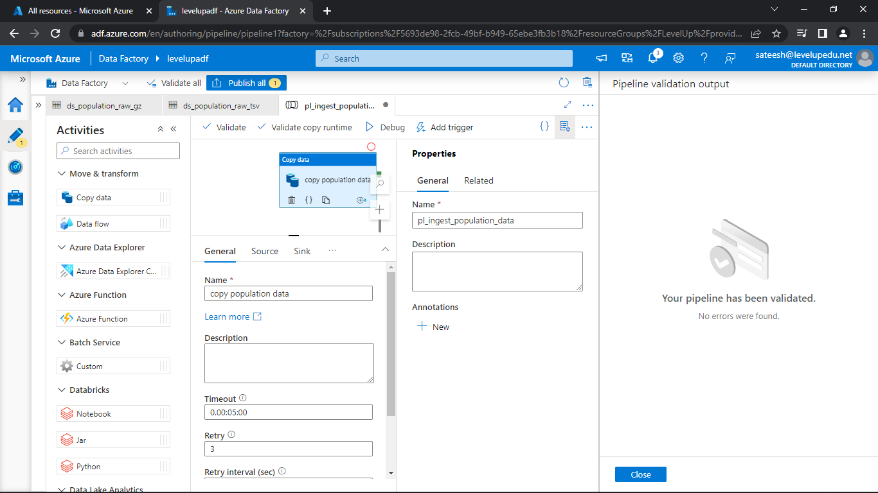

Now, click on debug

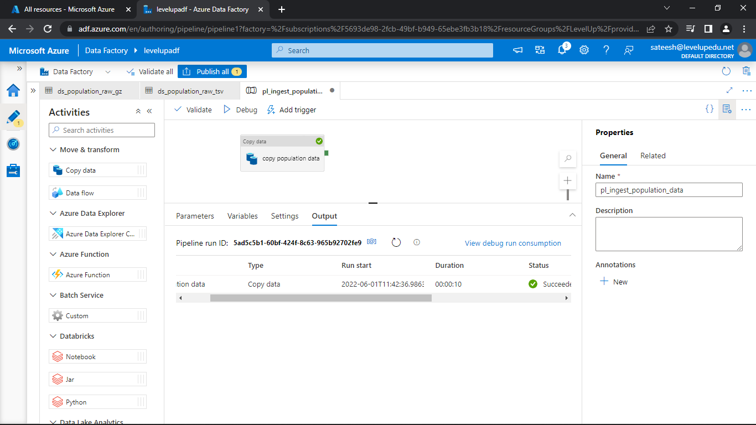

Now click on the Spectacles symbol next to the name and see the details of the pipeline.

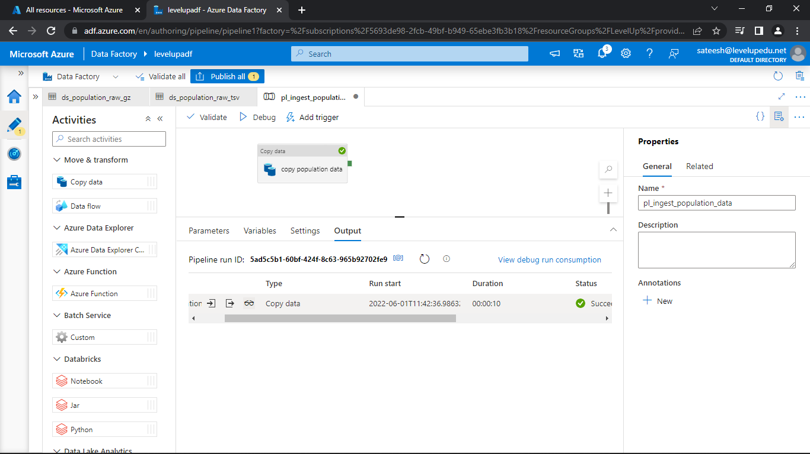

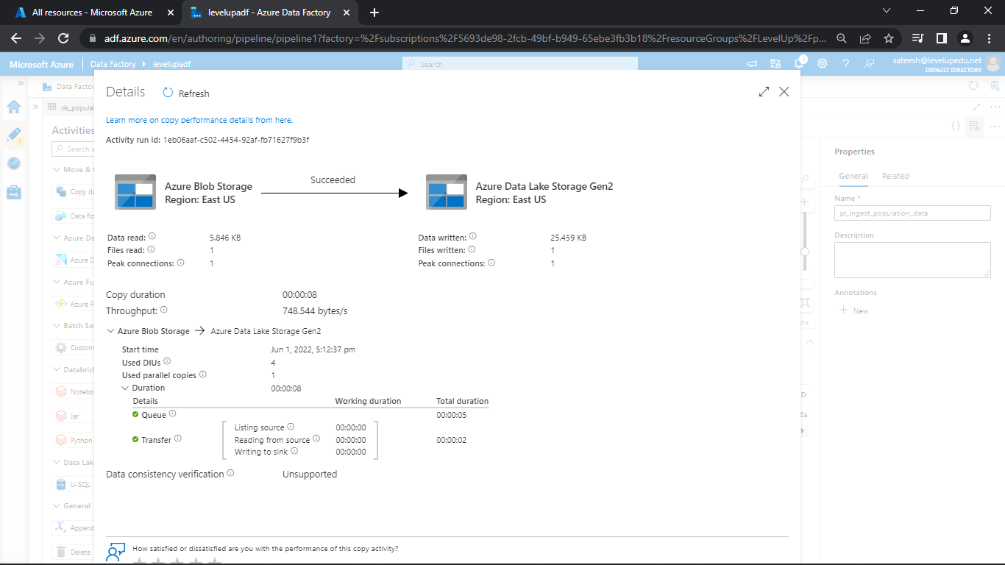

Click on publish all and save the file.

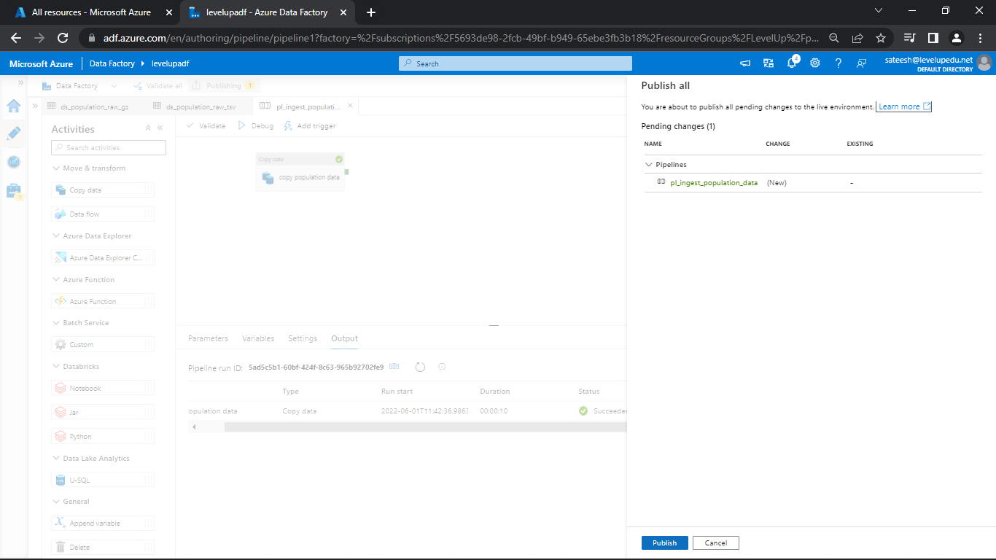

Go, to the dataset that created and give the file name as population and go back to the pipeline and debug.

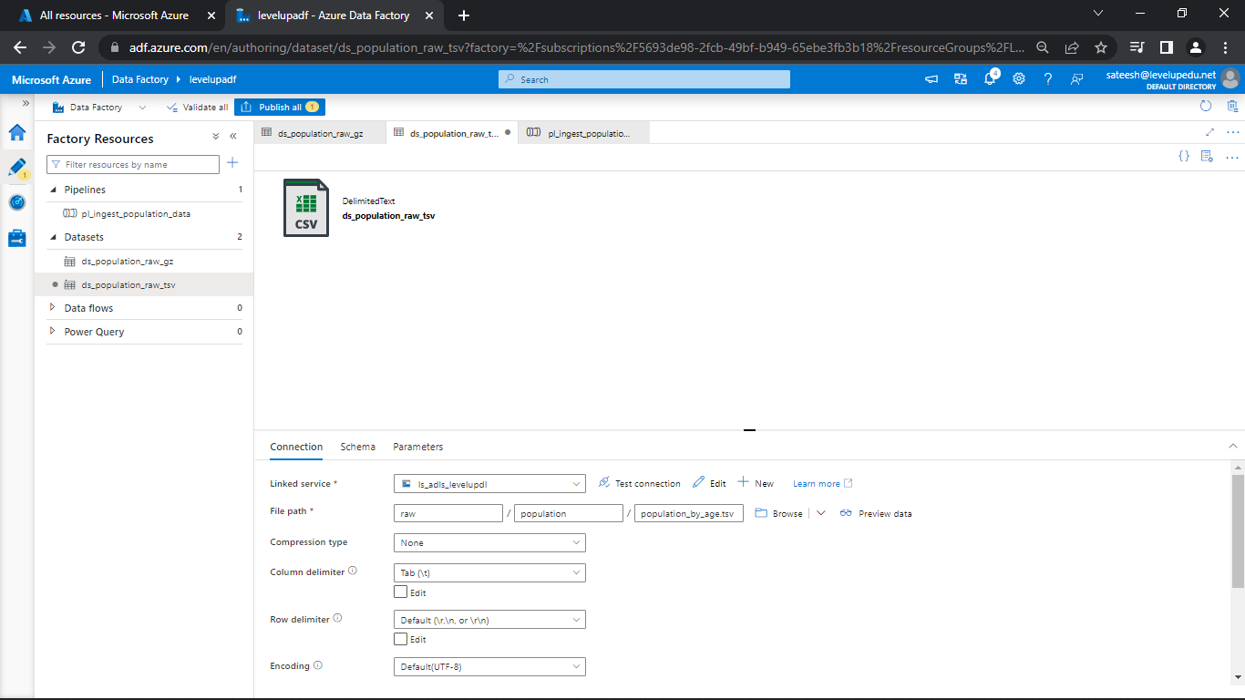

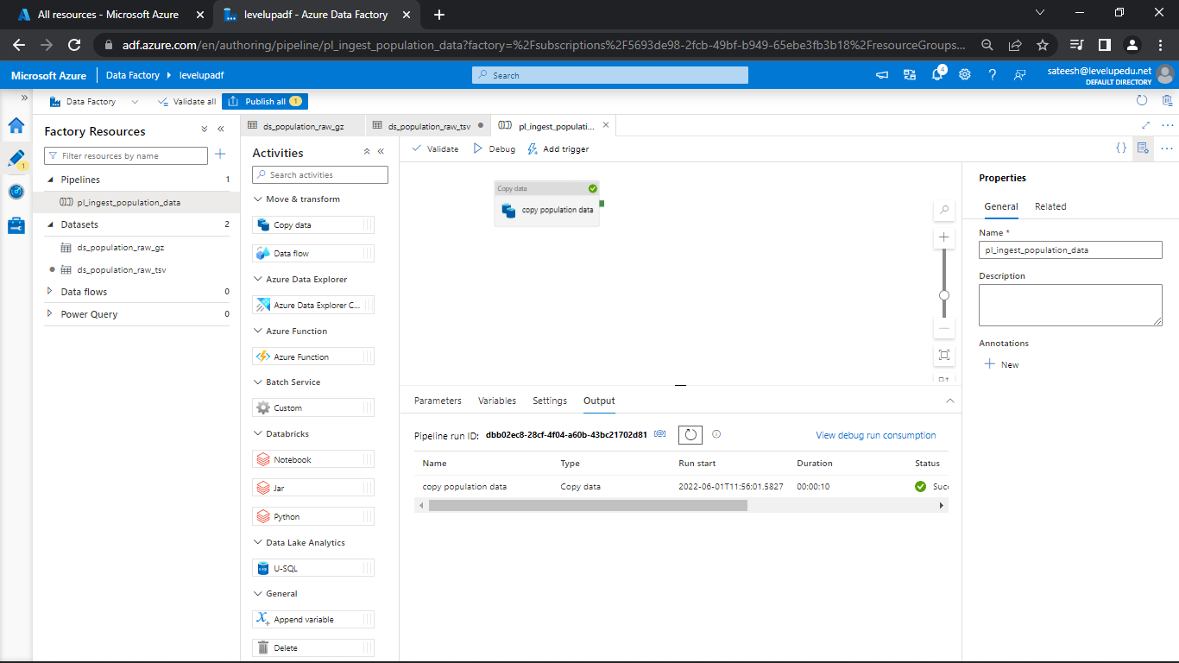

Now, go to the data lake storage and delete the old file which was not in the folder.

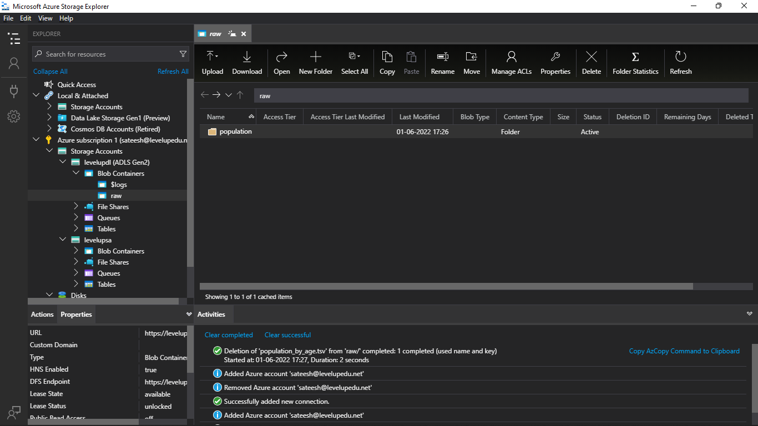

Click on the publish all and save the files.

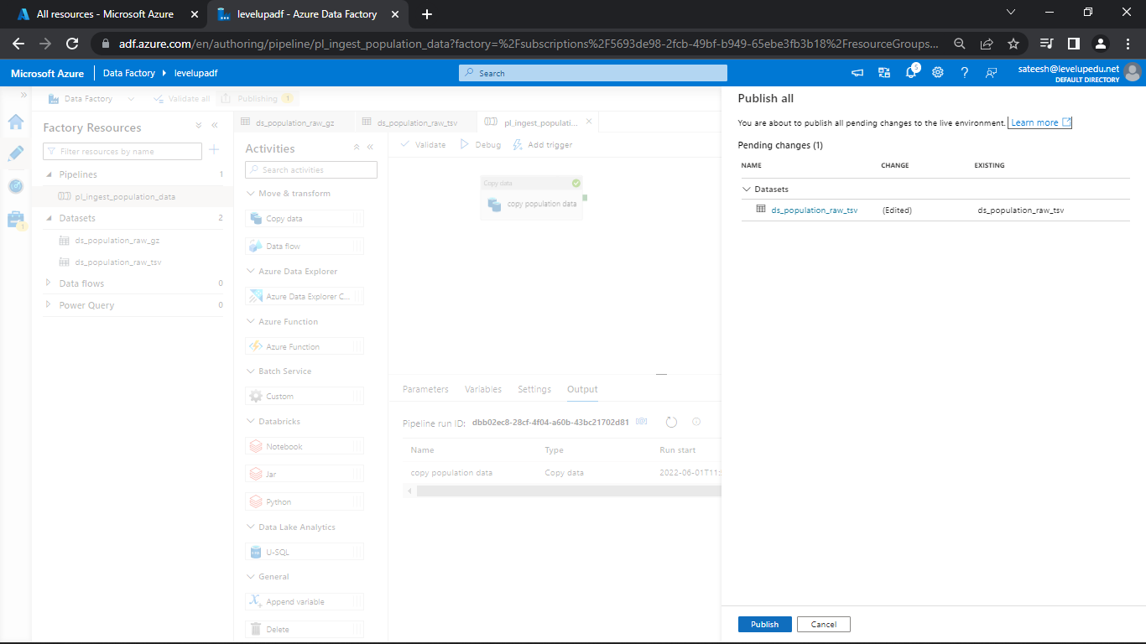

**Control Flow Activities (1) - Validation Activity**

**Scenario 1:** Execute the copy activity when the file is available

Change the name as required and pull the Validation activity into the pipeline pane

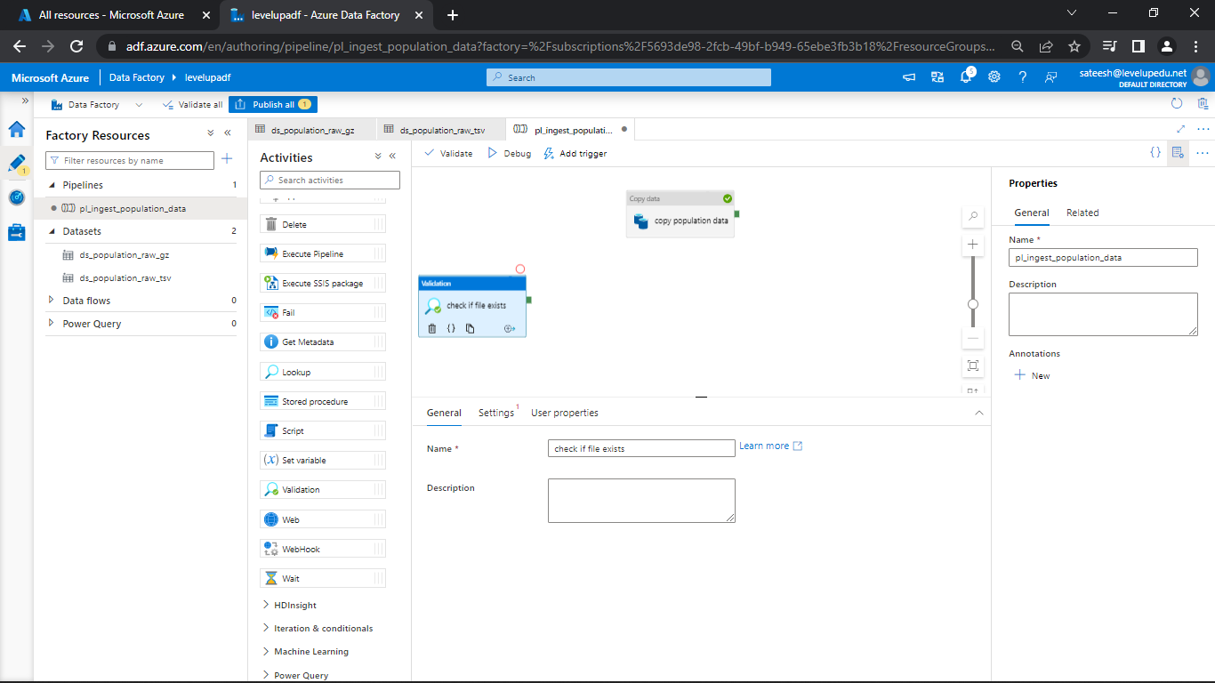

Go, to settings select the dataset

Change the timeout to 1 day

Change the sleep to 600

Change minimum size to 1024

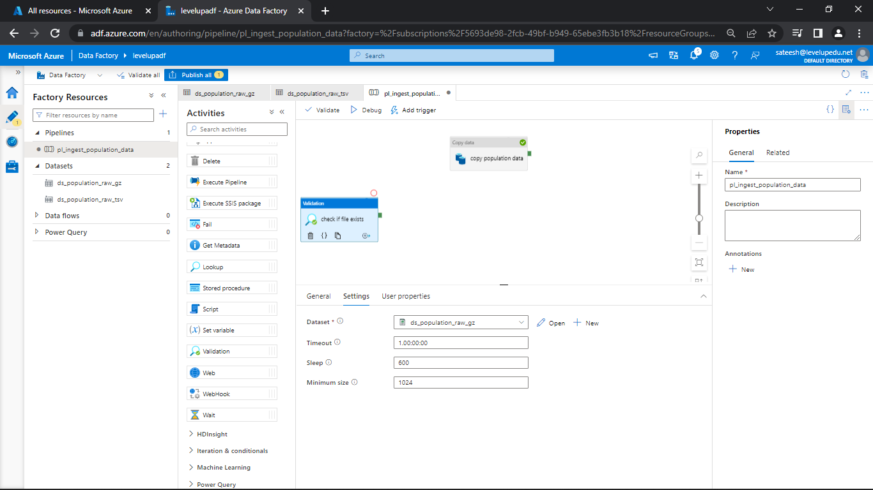

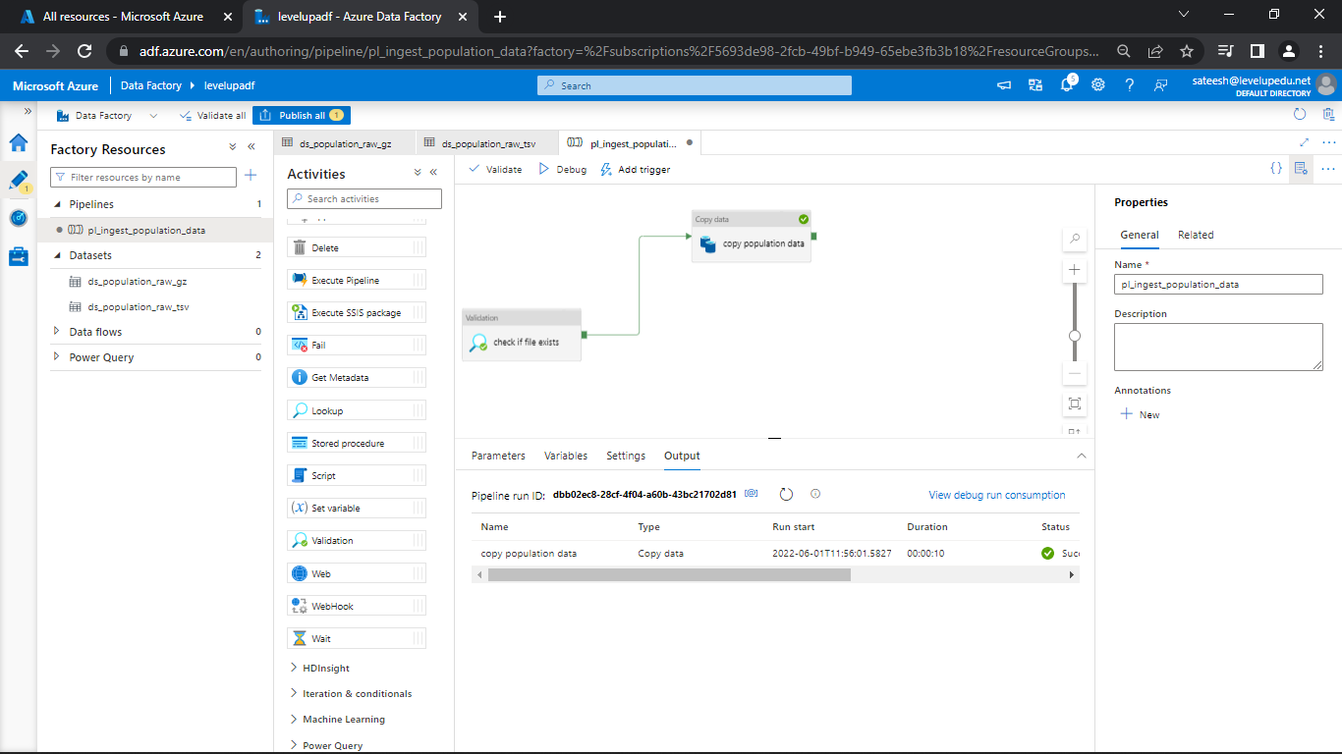

So, we want to make that one dependent on this one for what you do is you click on this green button here, which is on success, and then you drag it over to this activity.

So now this will only run when this activity succeeds.

**Control Flow Activities (2) - Get Metadata, If Condition, Web Activities**

**Scenario 2:** Execute copy activity only if files are as expected

Go to general and select metadata and drag to the pipeline pane.

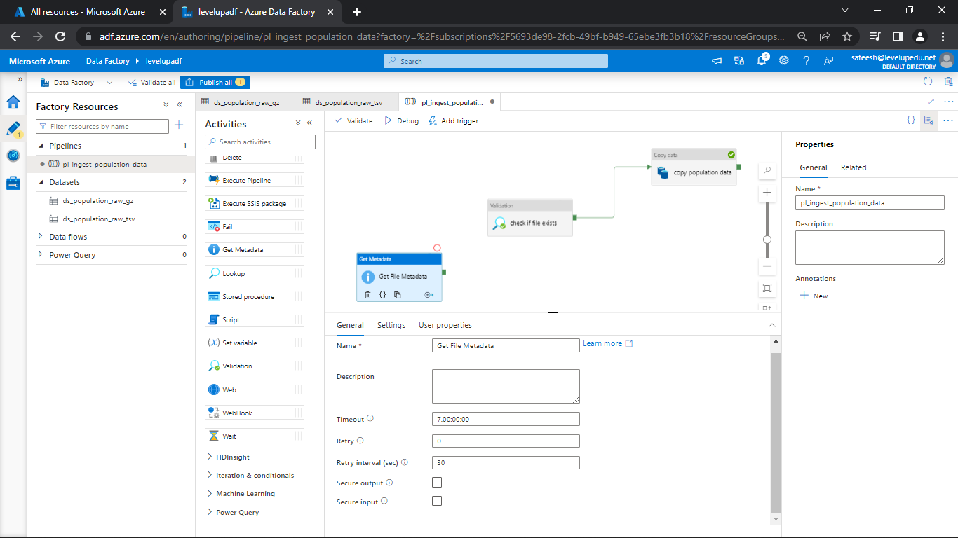

Change the file name if required and go to settings

Select the dataset

Click on New in the Field list and select the required Argument.

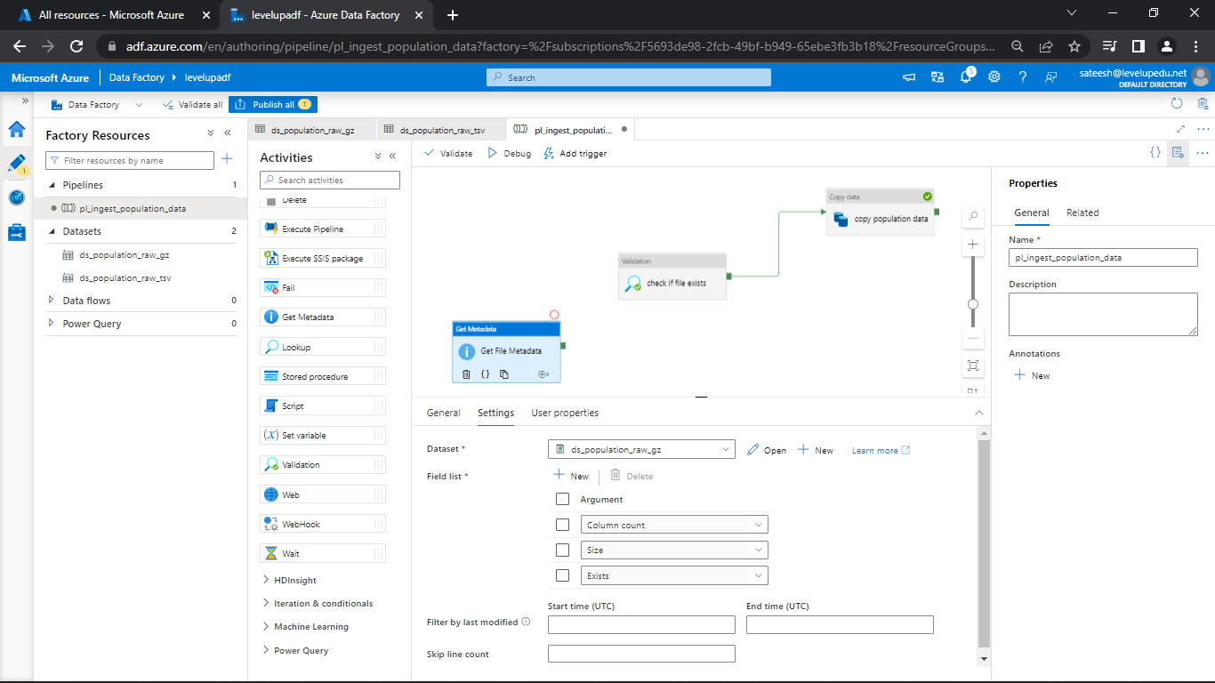

And click on Debug

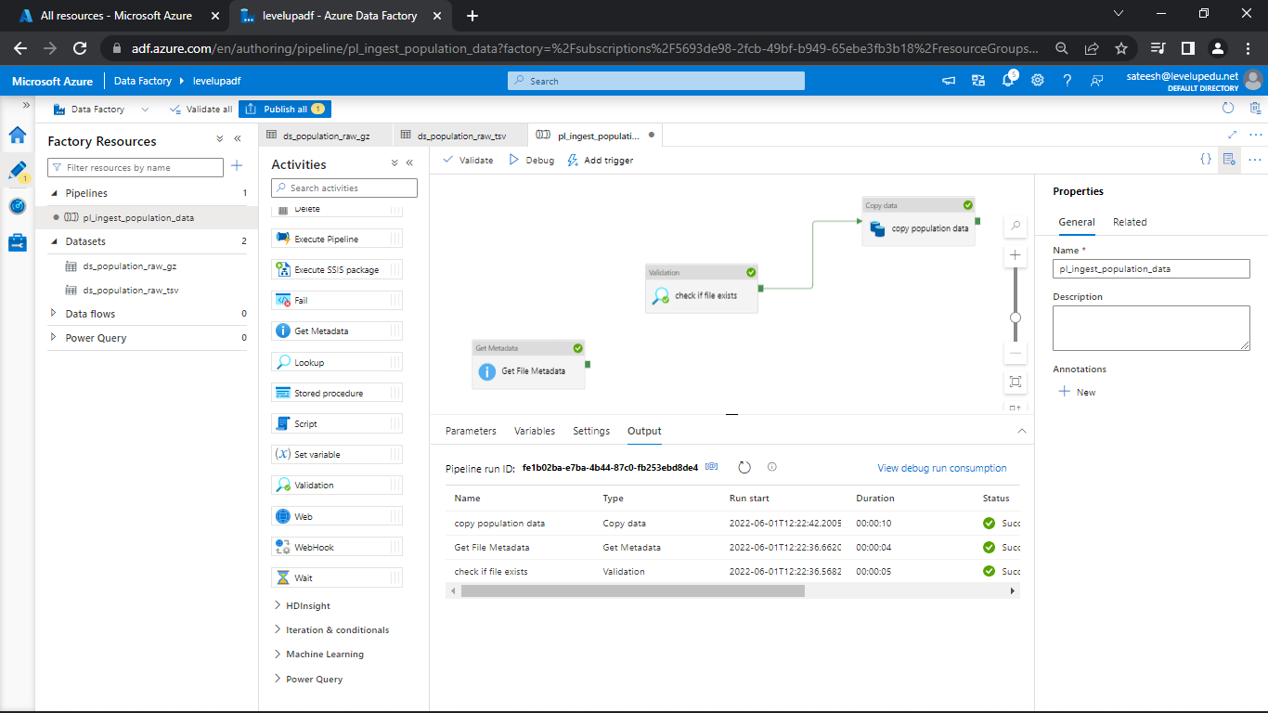

Check the output for the metadata

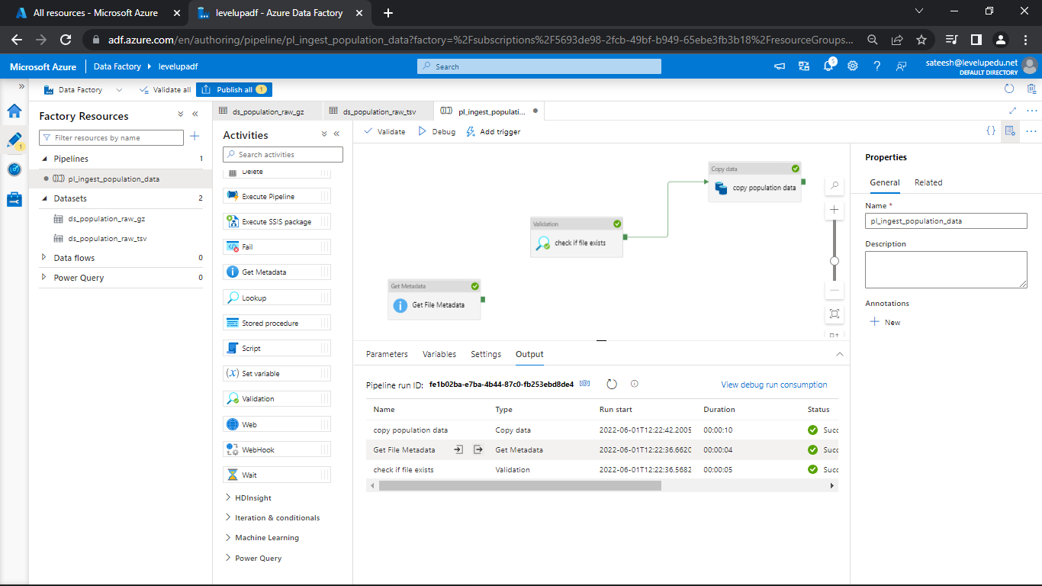

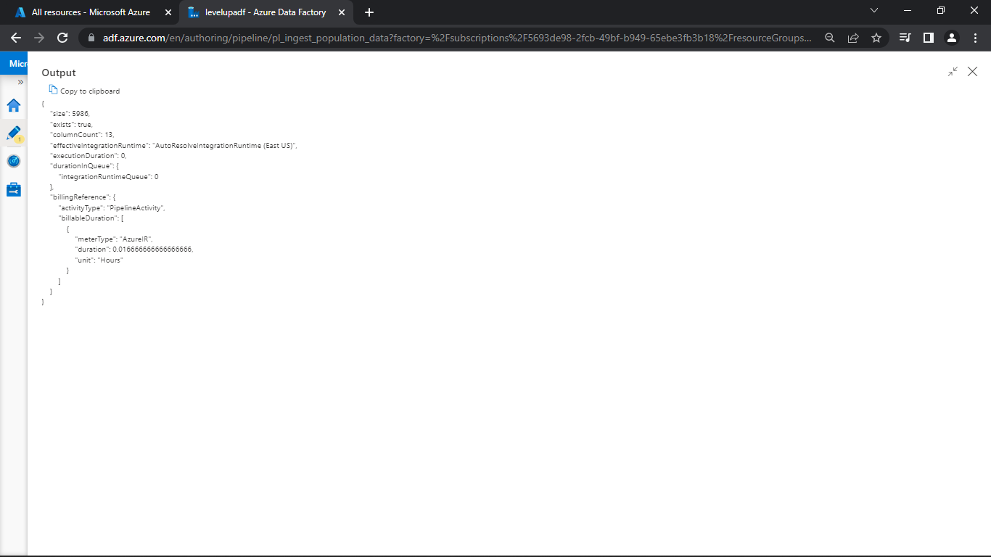

Now, go to the Iteration & conditionals and drag the if condition to the pipeline pane.

Change the name if required and move to Activities.

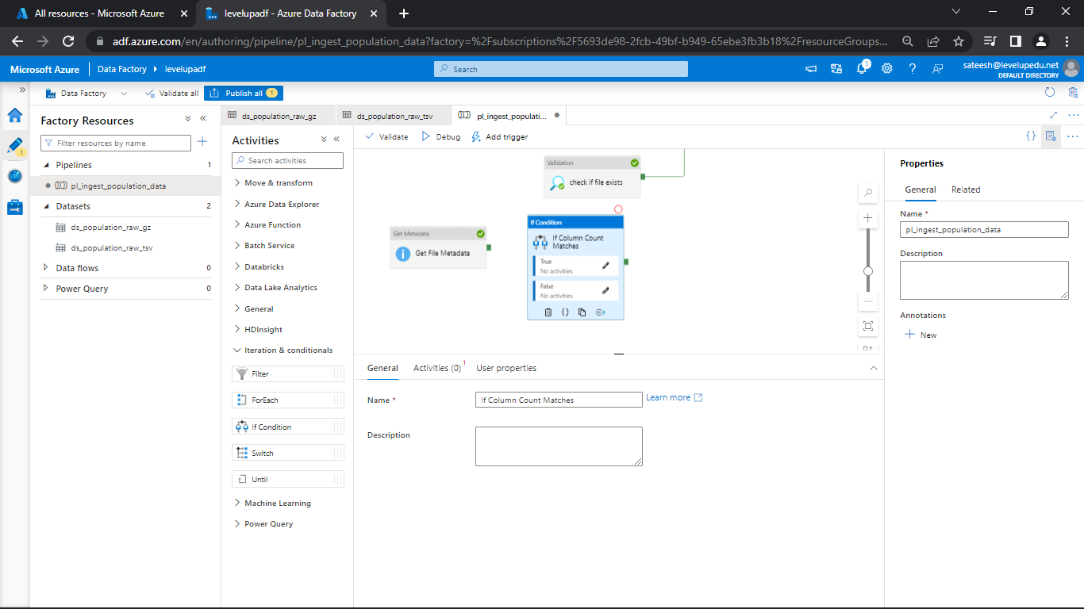

In Activities click on Add Dynamic Content

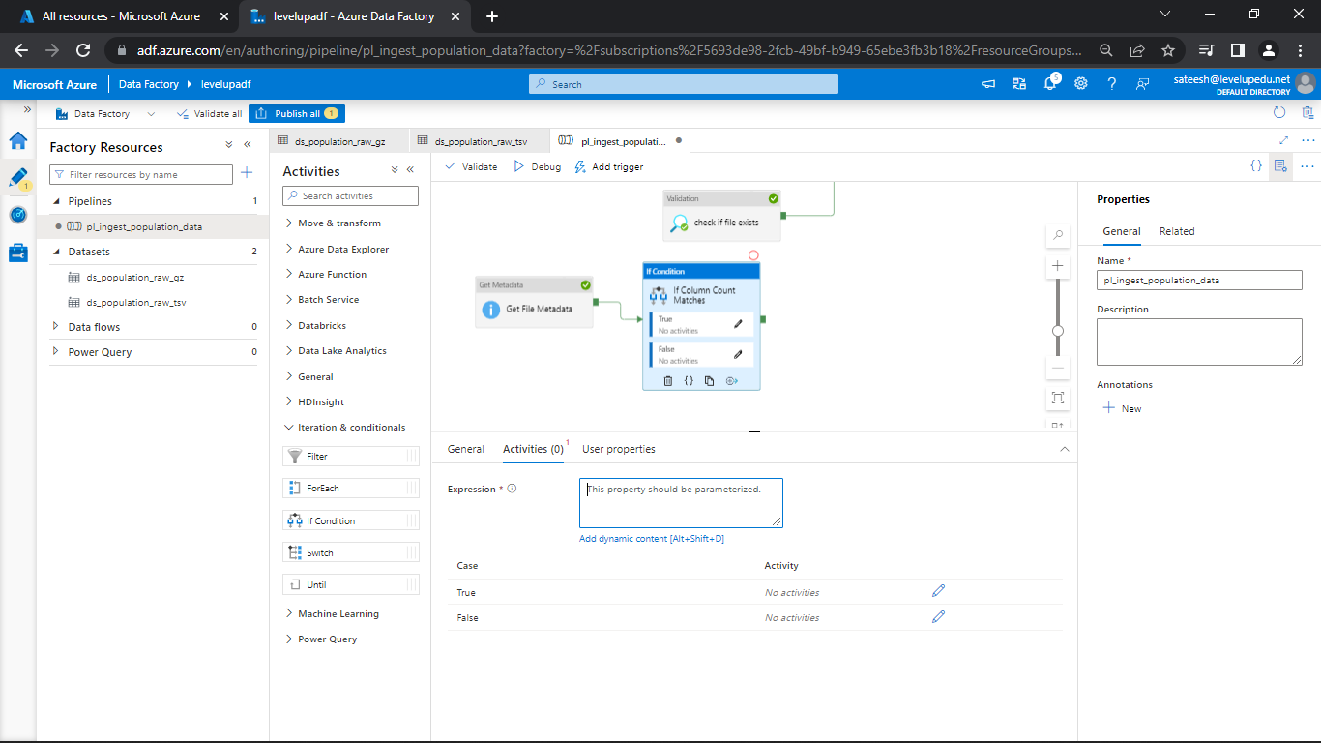

Go, to logical functions and select equal

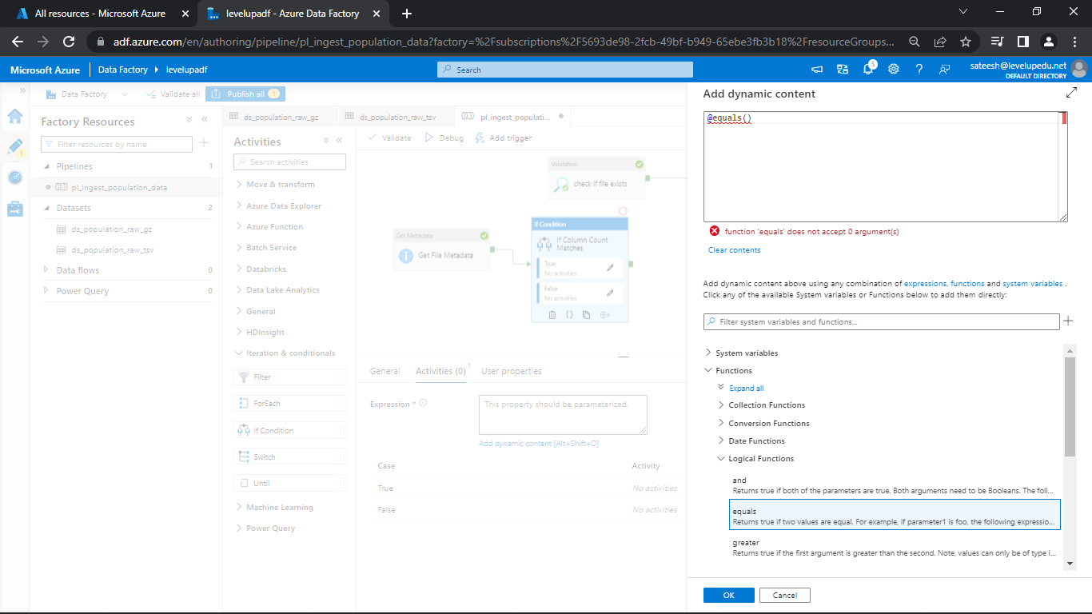

And select get file metadata from Activity Outputs

@**equals**(**activity**('Get File Metadata').output.columnCount, 13)

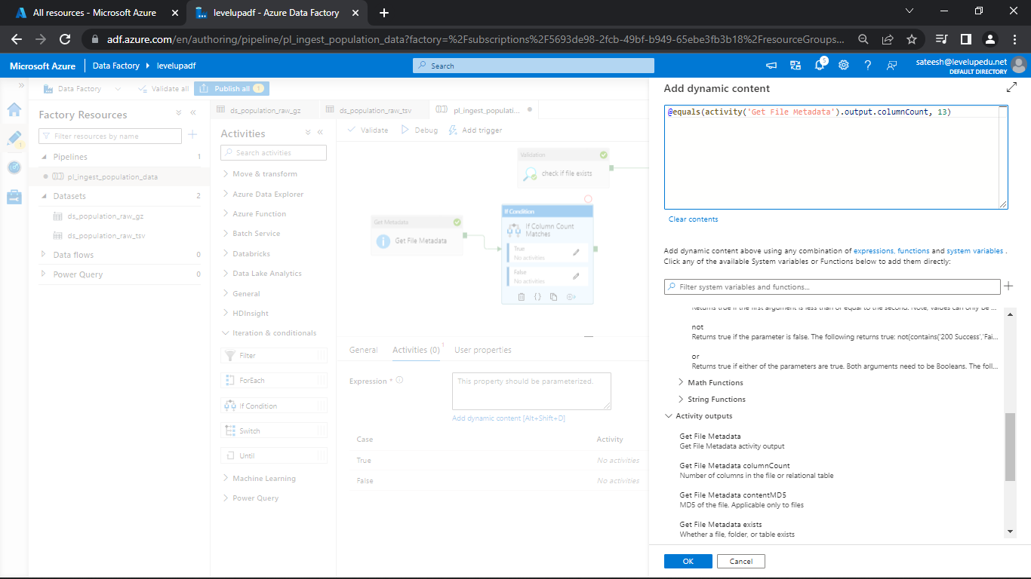

Click OK

Click on Copy Data and copy

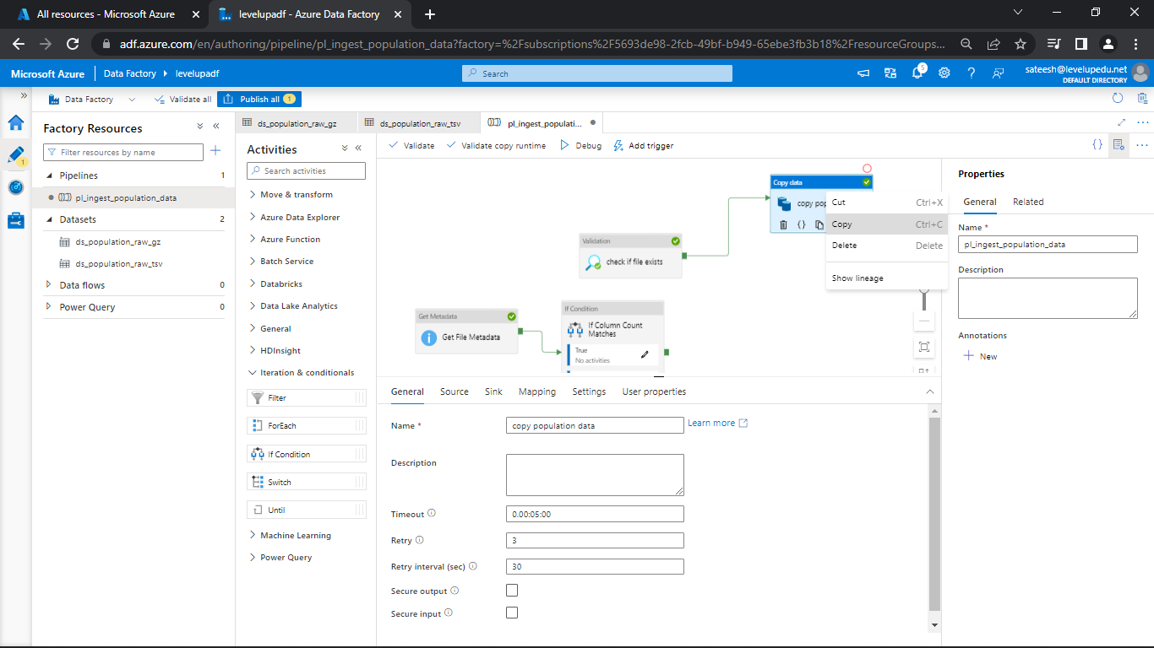

Now, go to the if condition and select pencil button next to True and paste.

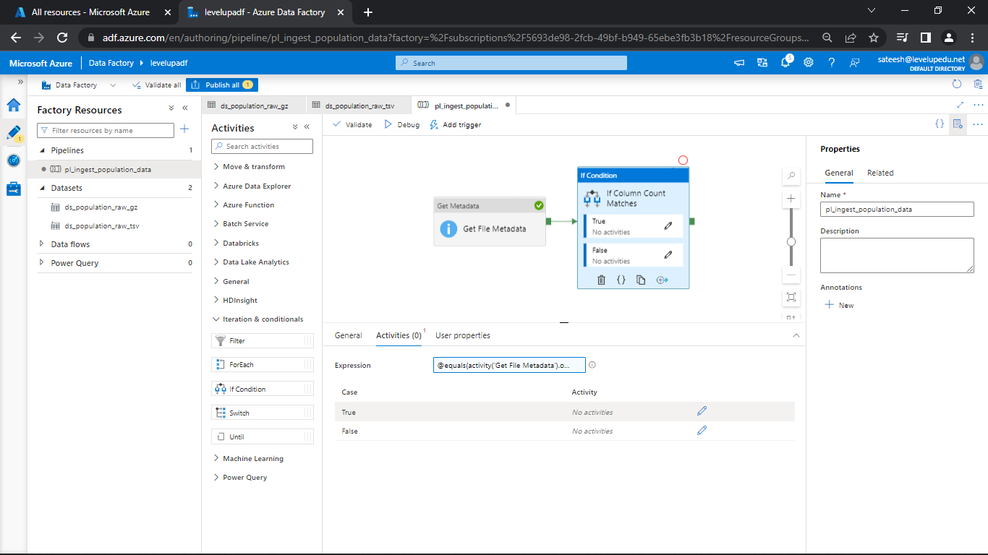

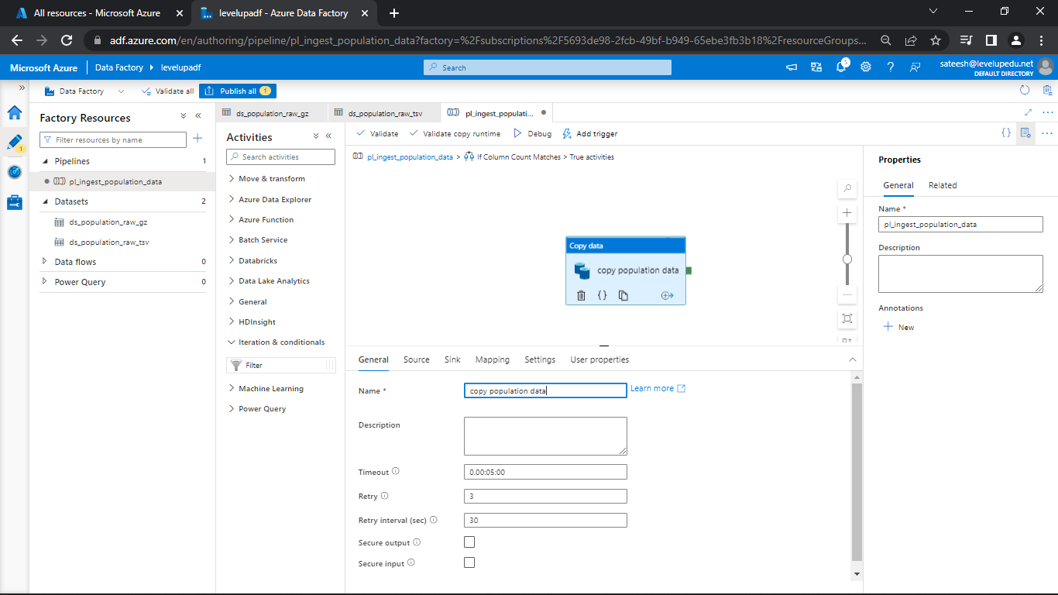

Now, delete the old copy data

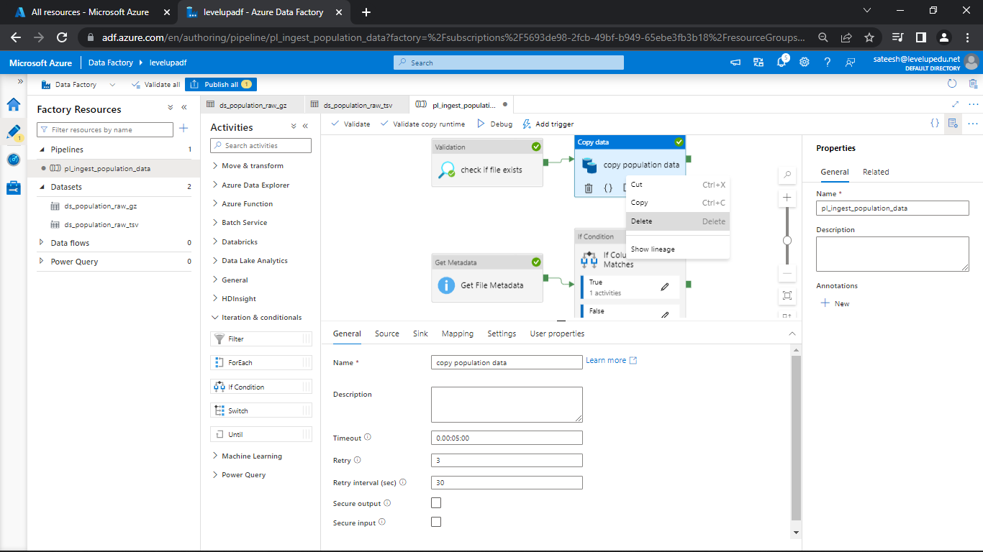

Connect check file exists with get file metadata

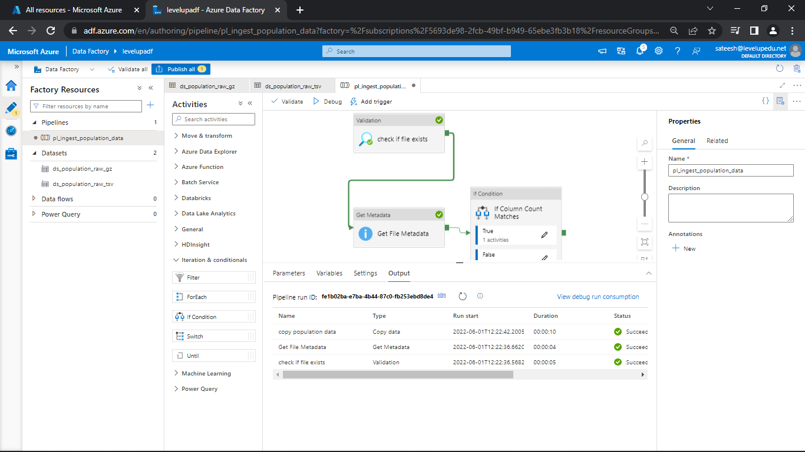

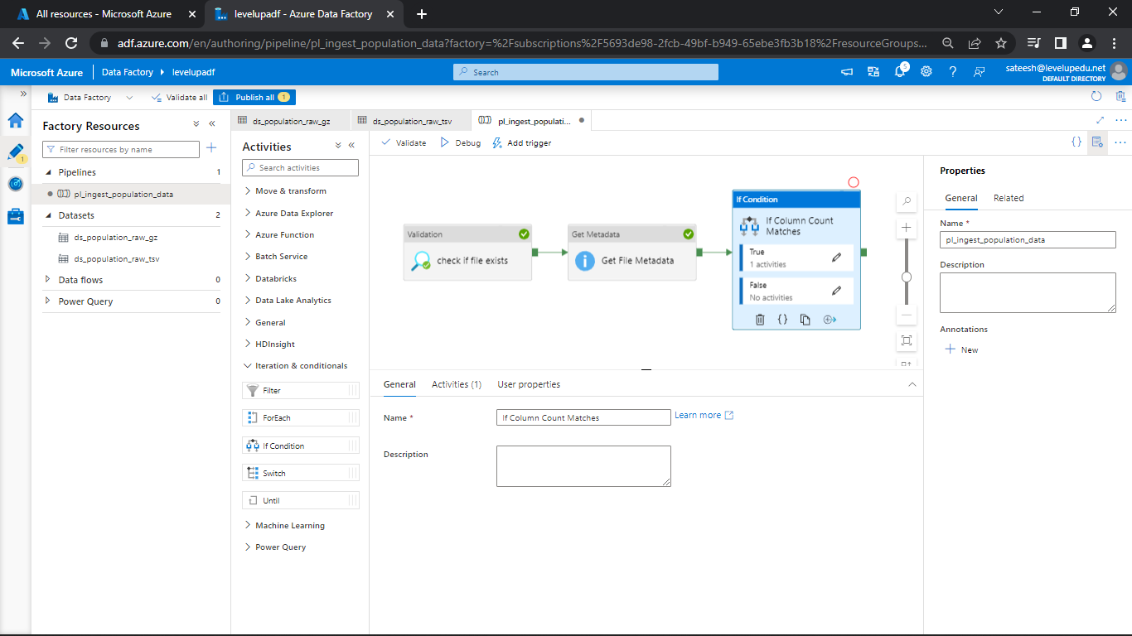

Now, click on debug

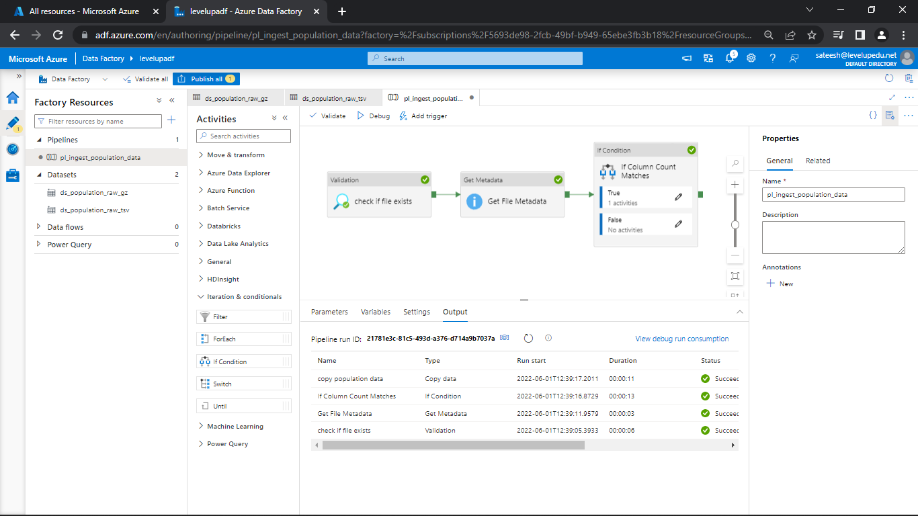

Go, to the if condition and change the count to 14 as we know the count is 13.

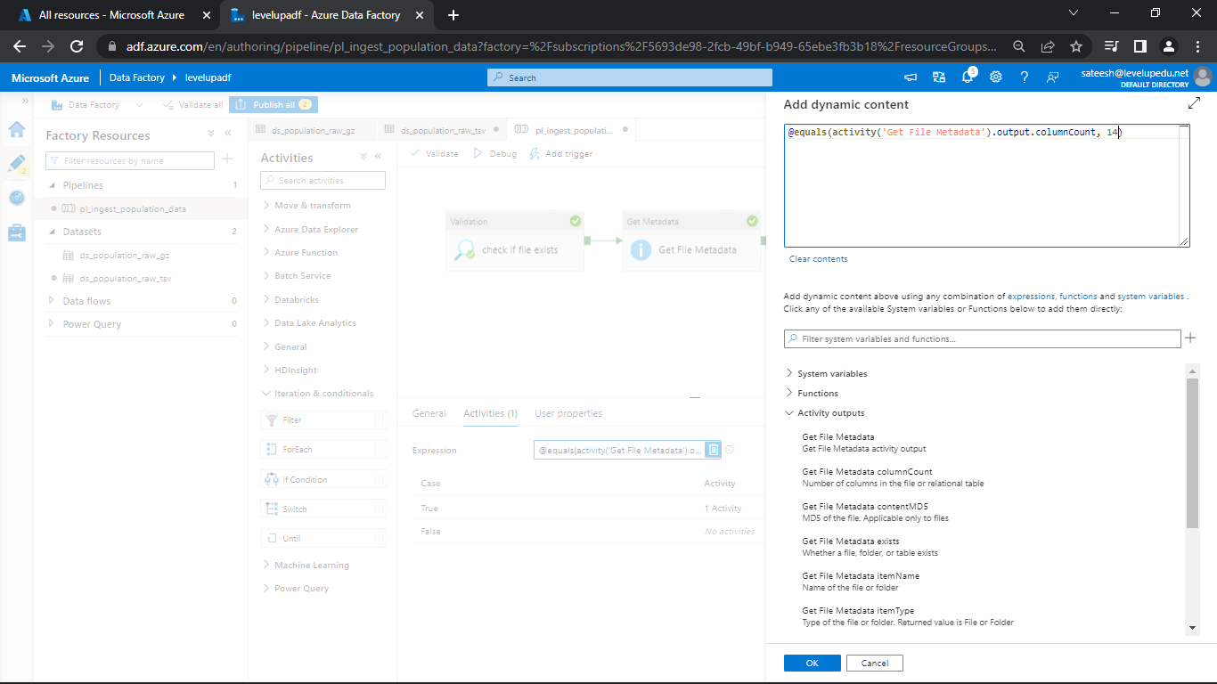

Now, debug

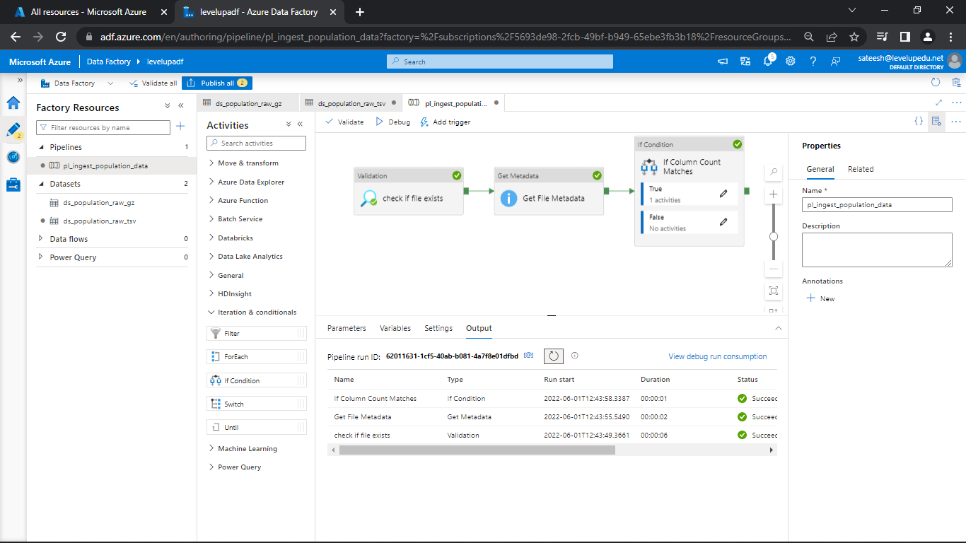

You can see that the pipeline got ended without running the copy data as the count do not match.

Now, click on if condition and click on the pencil icon next to false

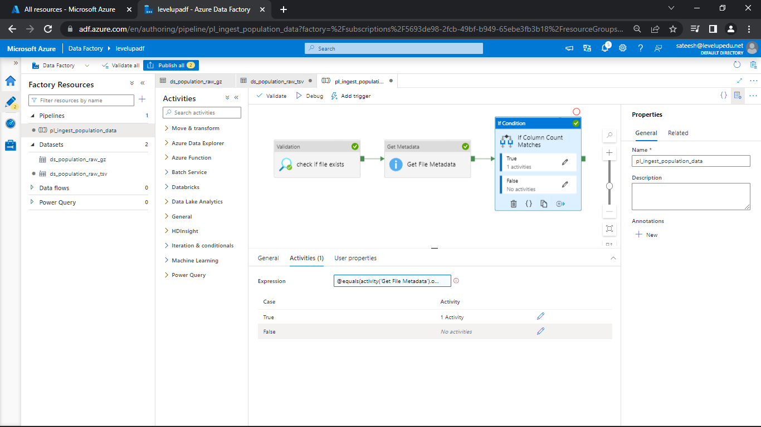

Now, click on general and drag web to the pipeline pane.

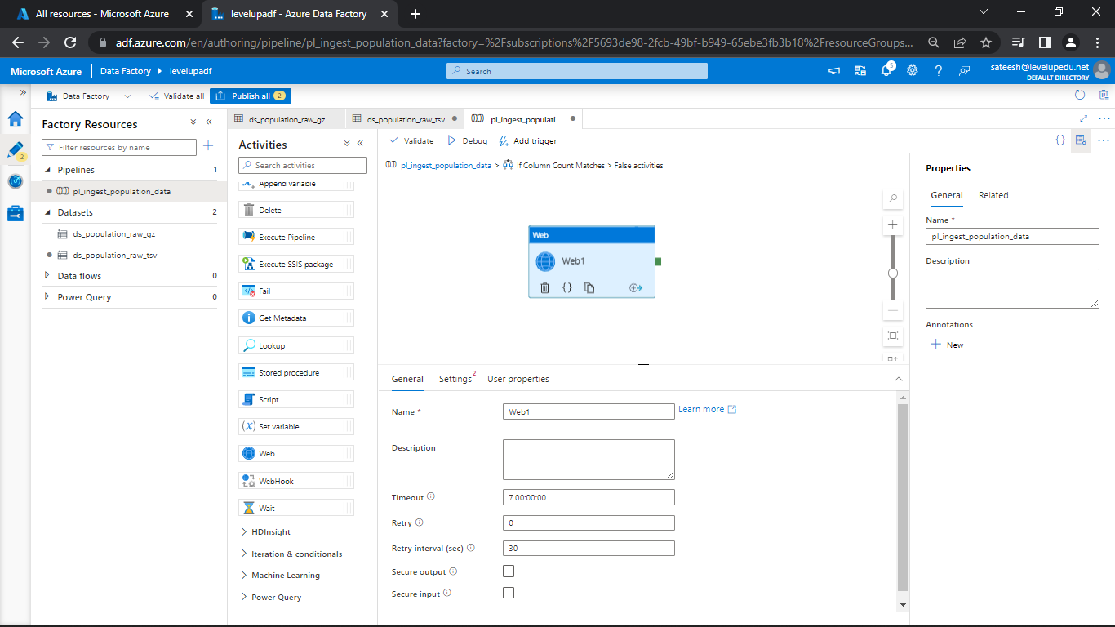

Change the name if required and click on Settings

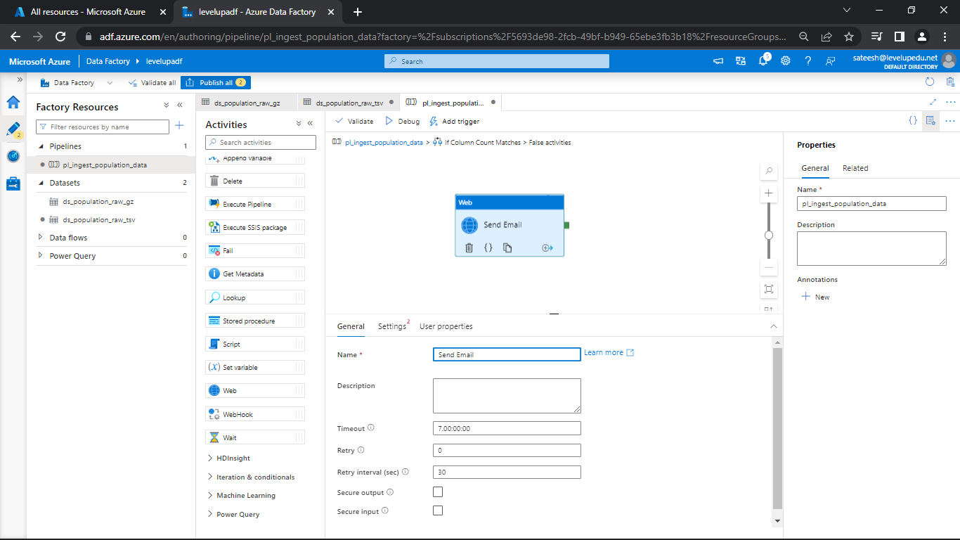

Give a URL if u have as I do not have just giving random

Select Method as POST and in body give it as dummy

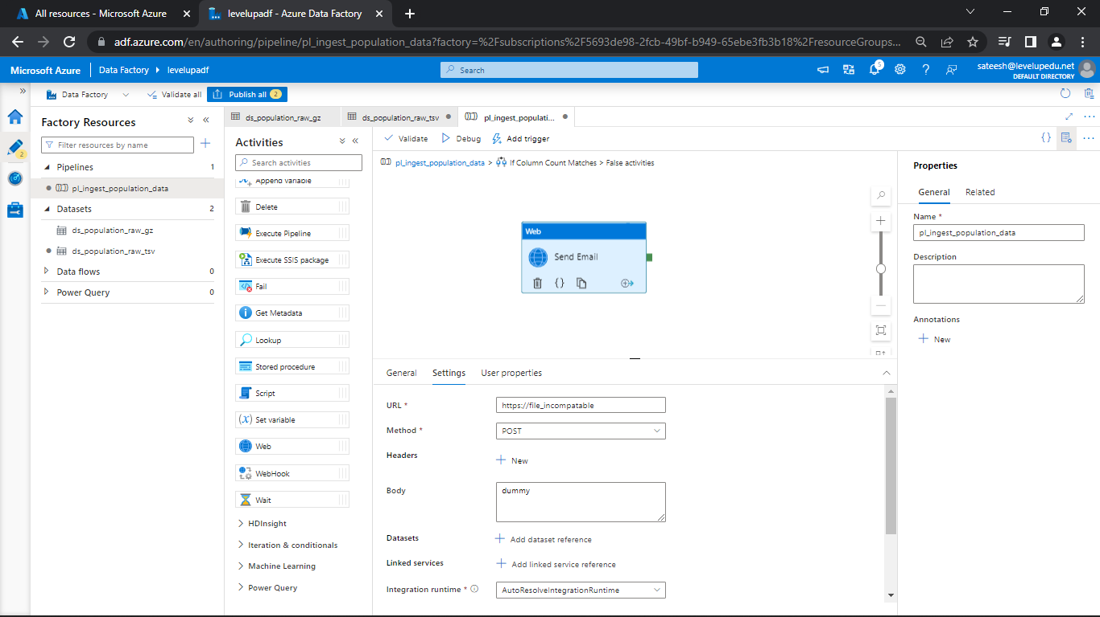

Now, go back to the pipeline and debug

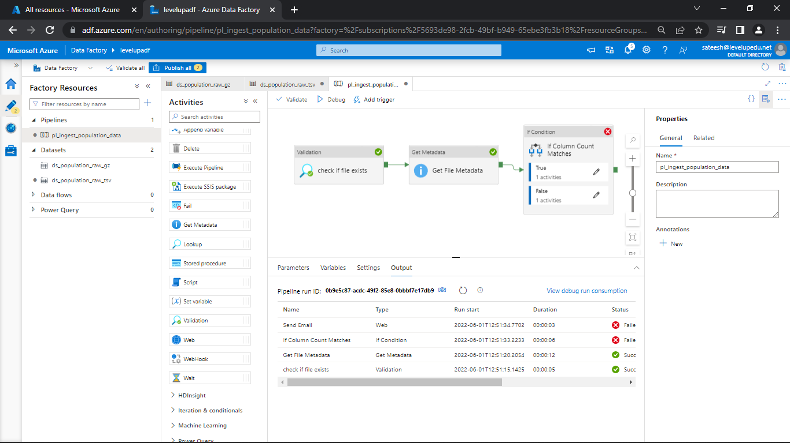

You can see the pipeline got failed

Check why the file got failed in message icon next to send email.

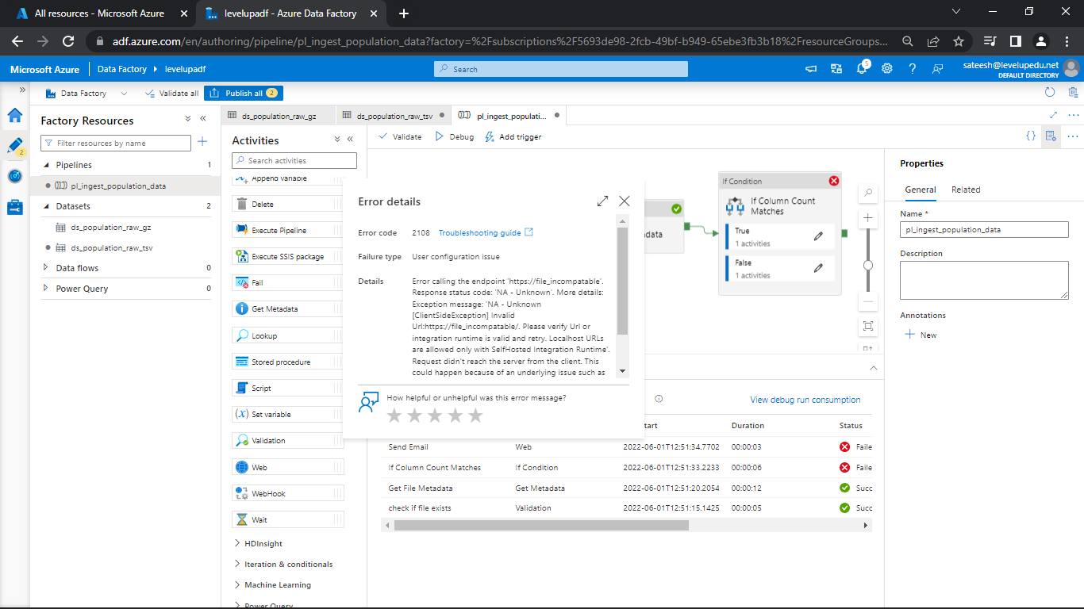

Now, change the count back to 13 and publish all

**Control Flow Activities (3) - Delete Activity**

**Scenario 3:** Delete the Source file on Successful Copy

Click on the pencil icon next to true in if condition

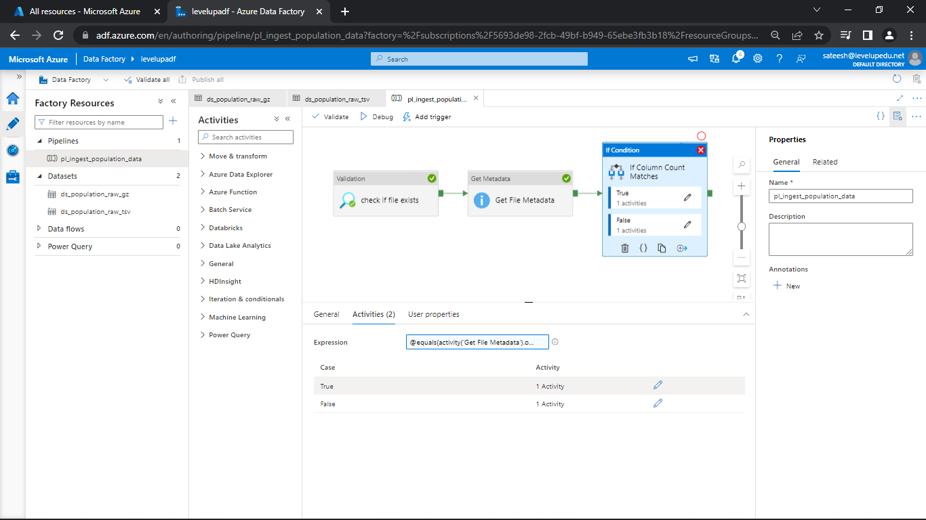

Add delete from general and drag to pipeline pane.

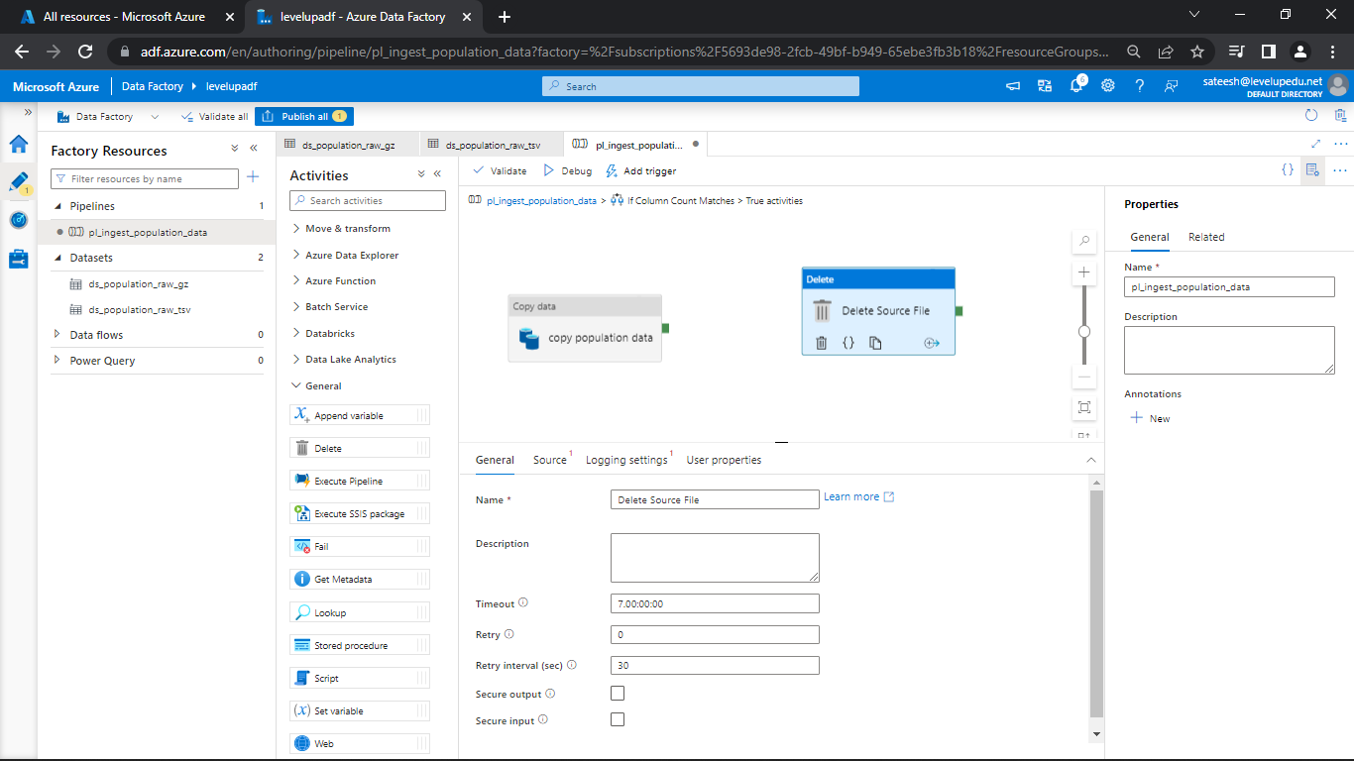

Change the name if required and go to source

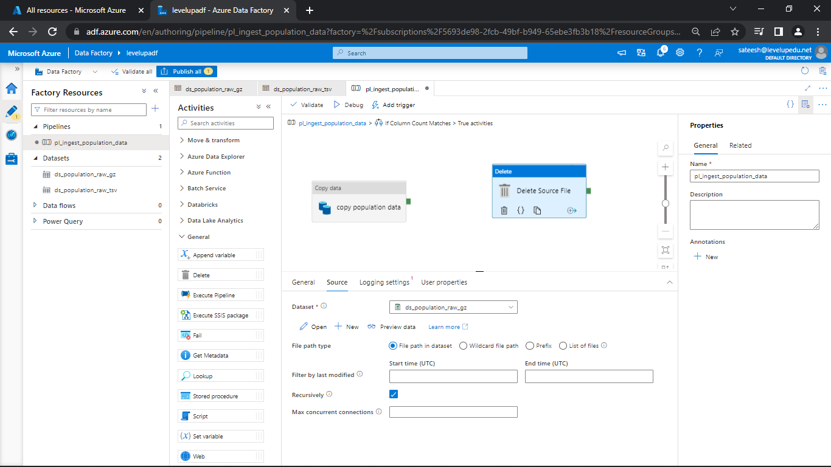

Select the dataset and go to Logging settings

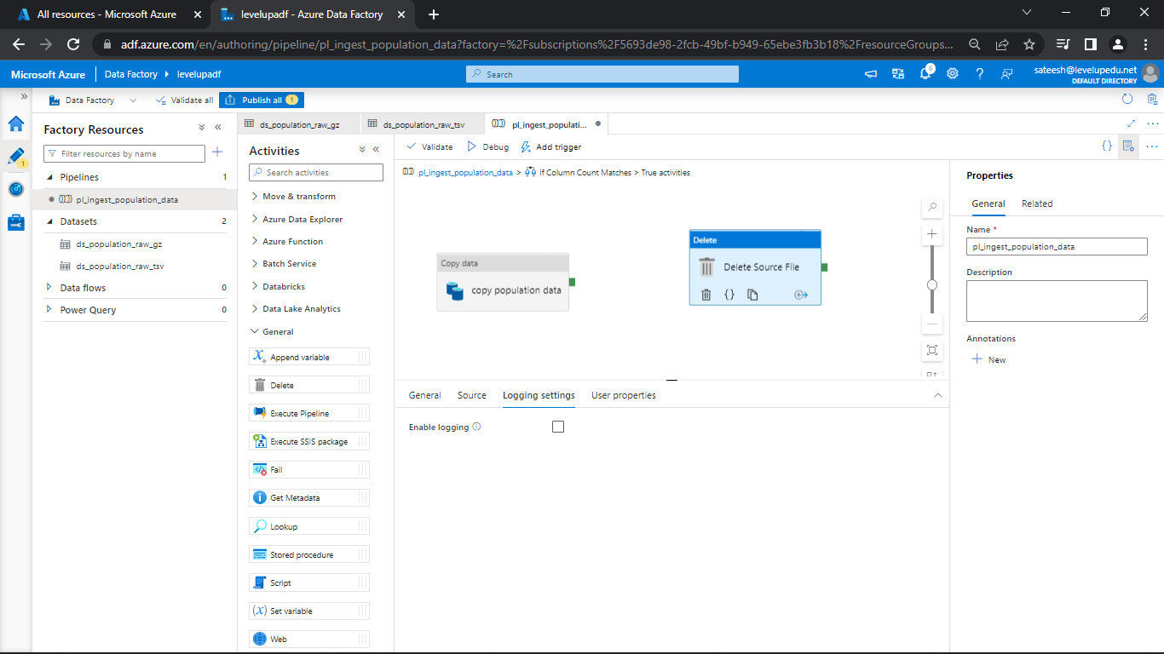

And deselect the Enable logging

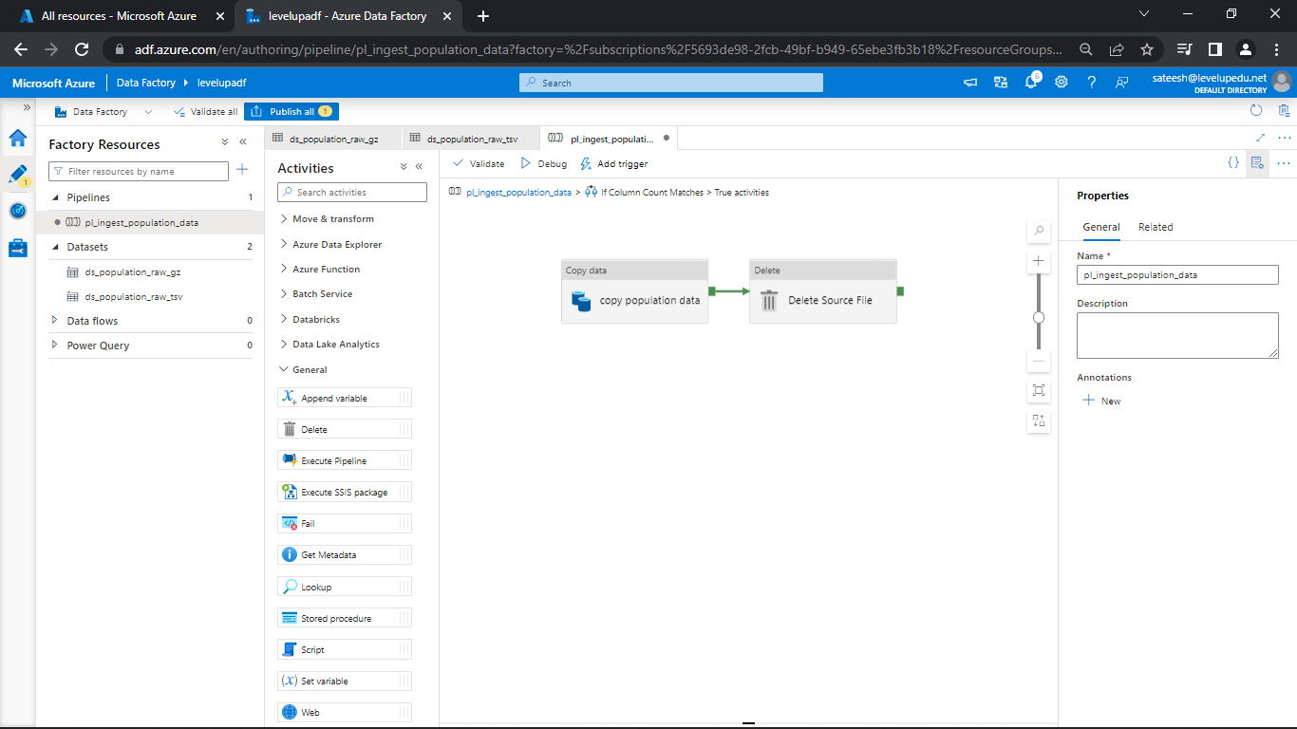

Draw the connection between copy data and Delete source file and debug

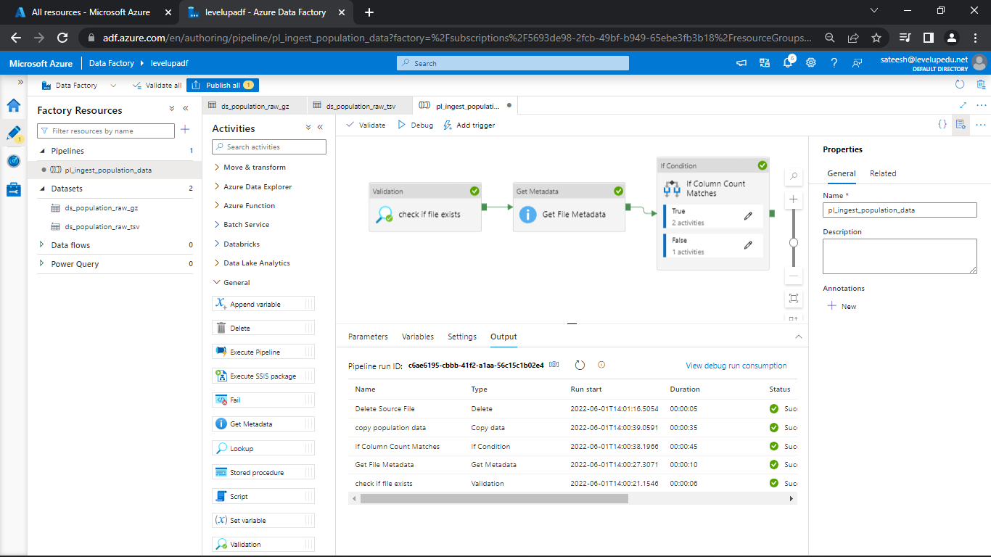

Before debugging check whether the file is there or not and later on check whether the file is deleted or not.

As u can see the file has been deleted.

**Creating Event Trigger**

Click on Manage in ADF and select triggers

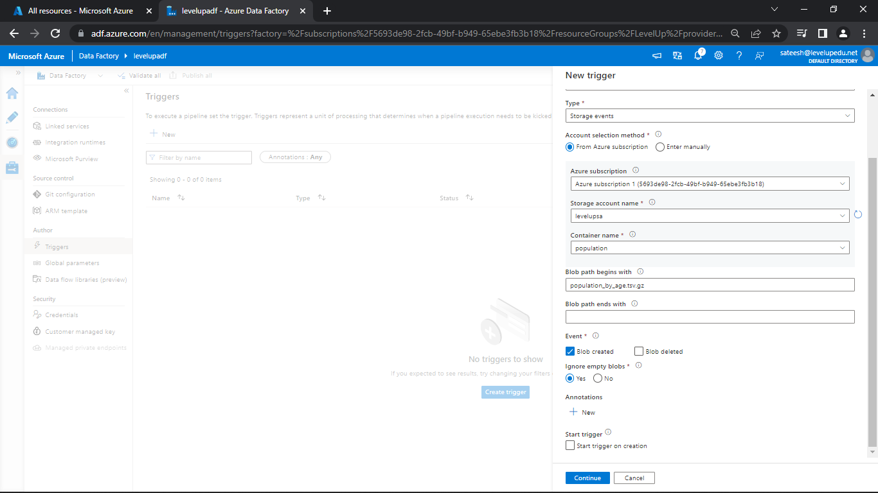

Select the Type as Storage Events

Select the Subscription, Storage Account name and Container name.

Type the Blob path begins as population_by_age.tsv.gz

Enable Blob Created and click continue and then OK

There you can see an error.

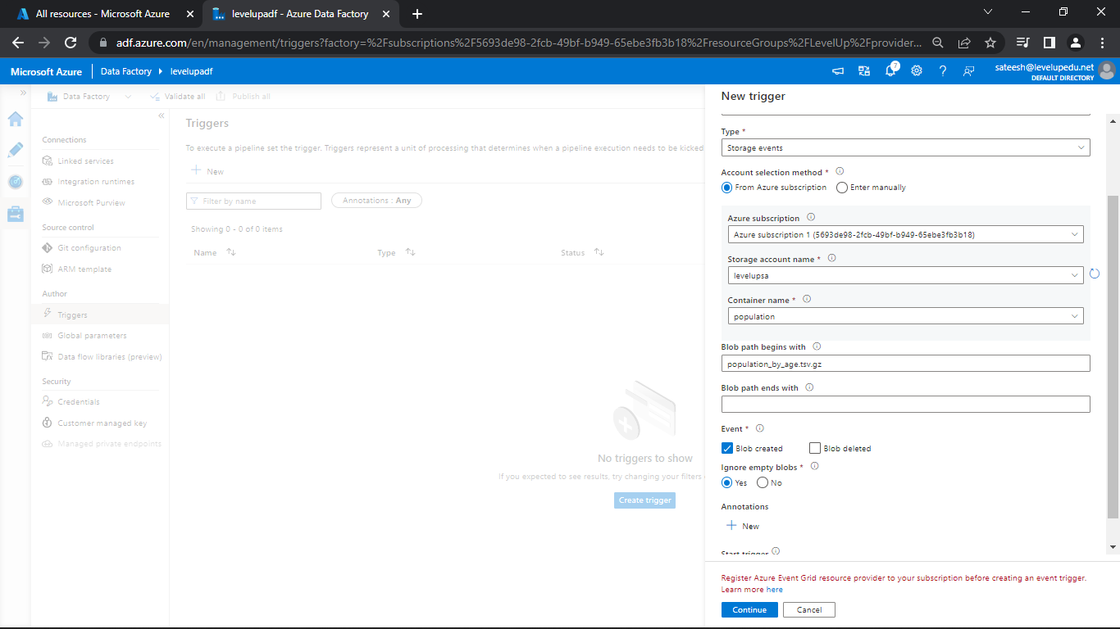

So, create an Azure Event Grid Subscription

Search for subscriptions in portal.azure.com and click on the subscription

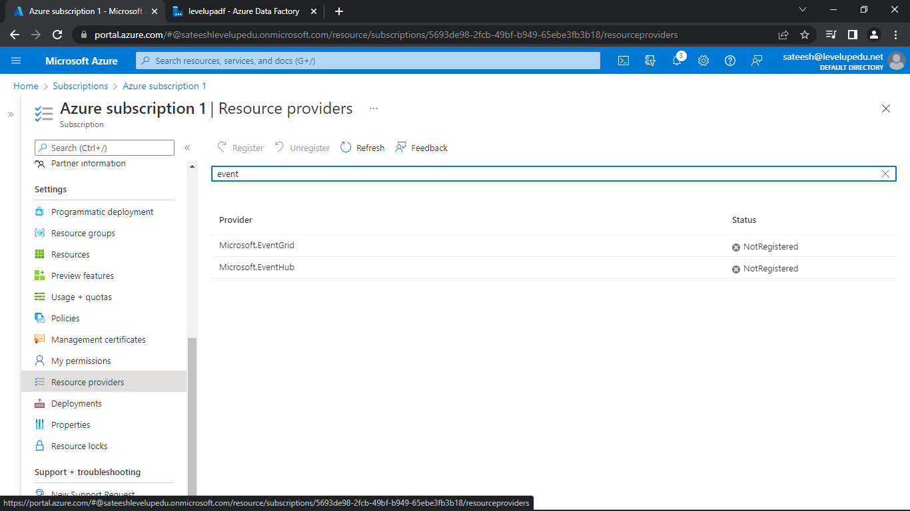

Click on Resource Providers and search for EventGrid

Select EventGrid and click register, it will take sometime please wait.

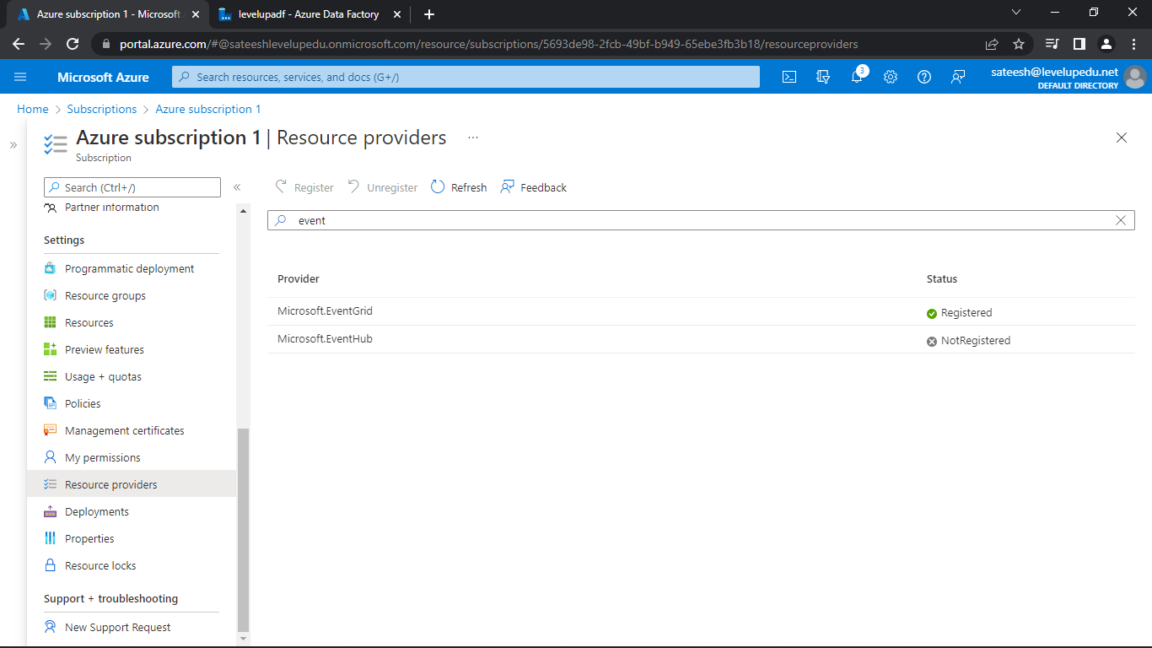

Later, go to ADF and create the trigger

Now, you can see the trigger has been created and publish all.

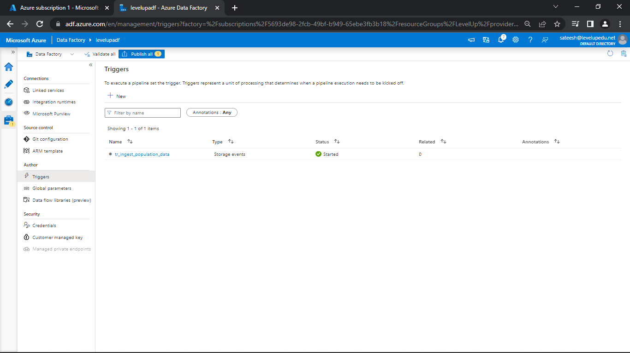

As, you can see there was an error.

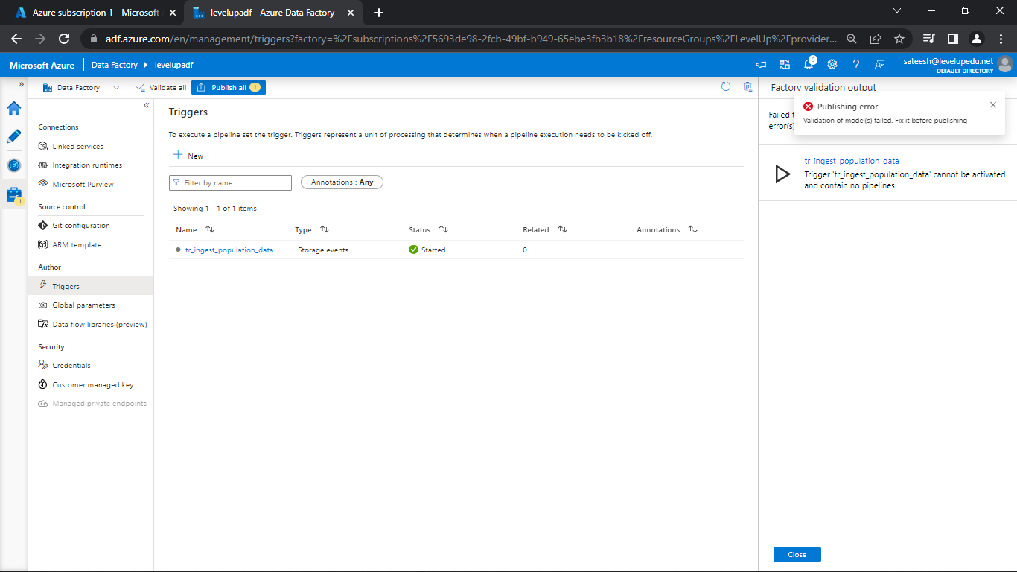

As, we haven’t attached the trigger so there was an error.

Now, go to the pipeline and attach the trigger

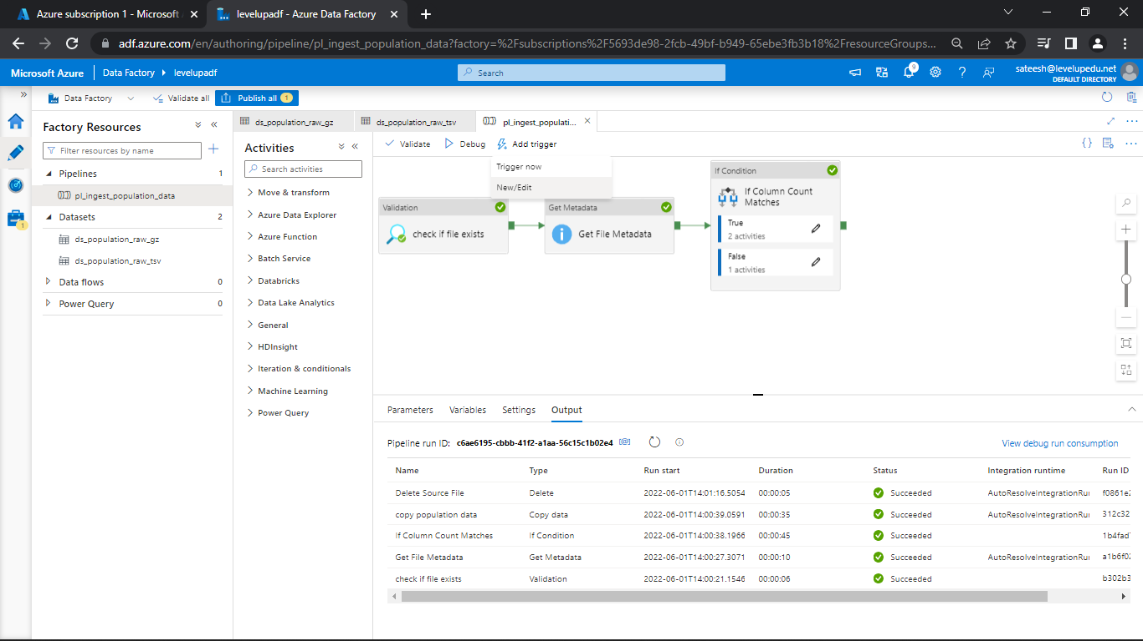

Click on New and select the trigger created and attach.

Now, publish all so that the data is saved.

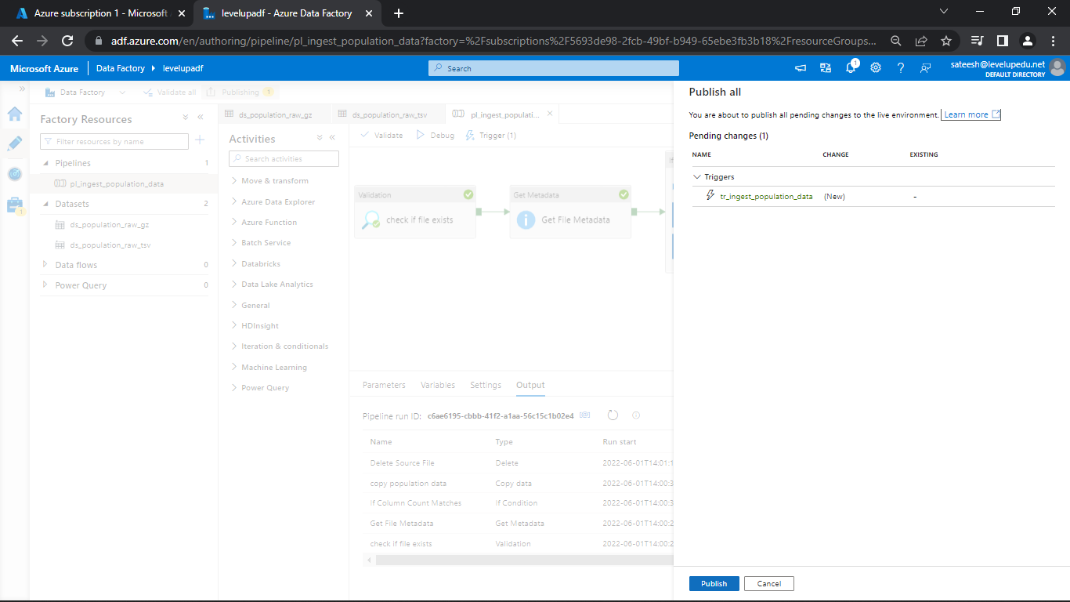

As, you can remember we have deleted the file in Storage

So, please upload the file in the container

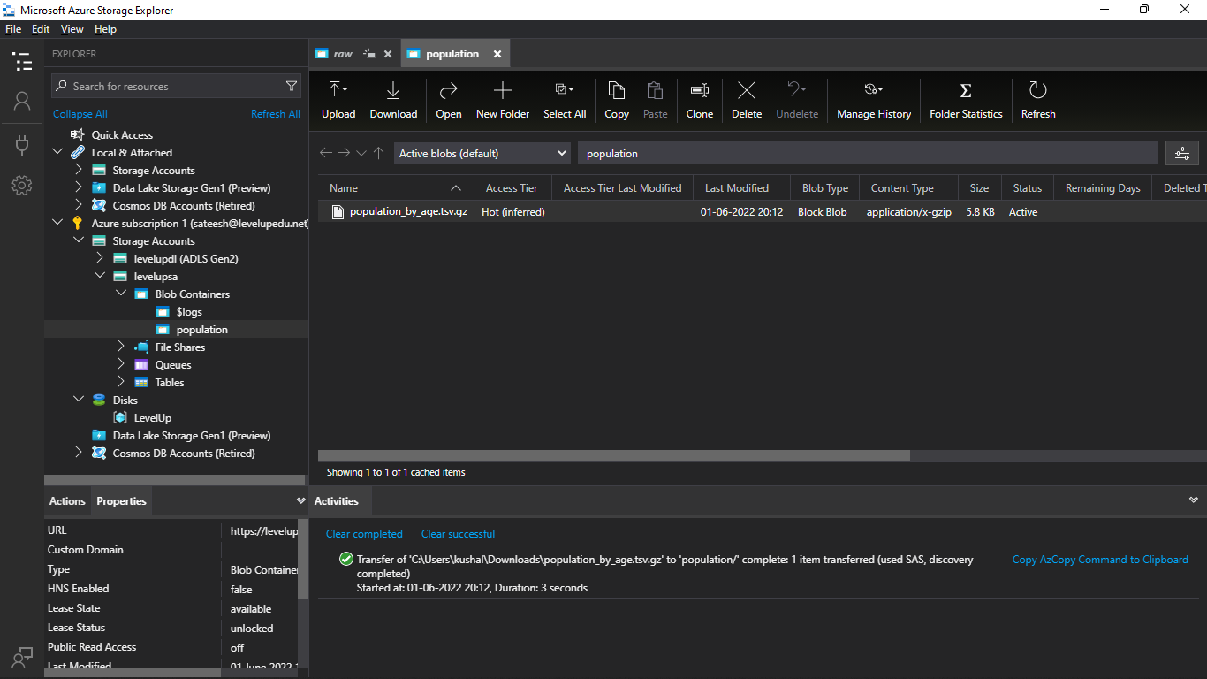

Now, go to the monitor and select Trigger runs and see the file uploaded

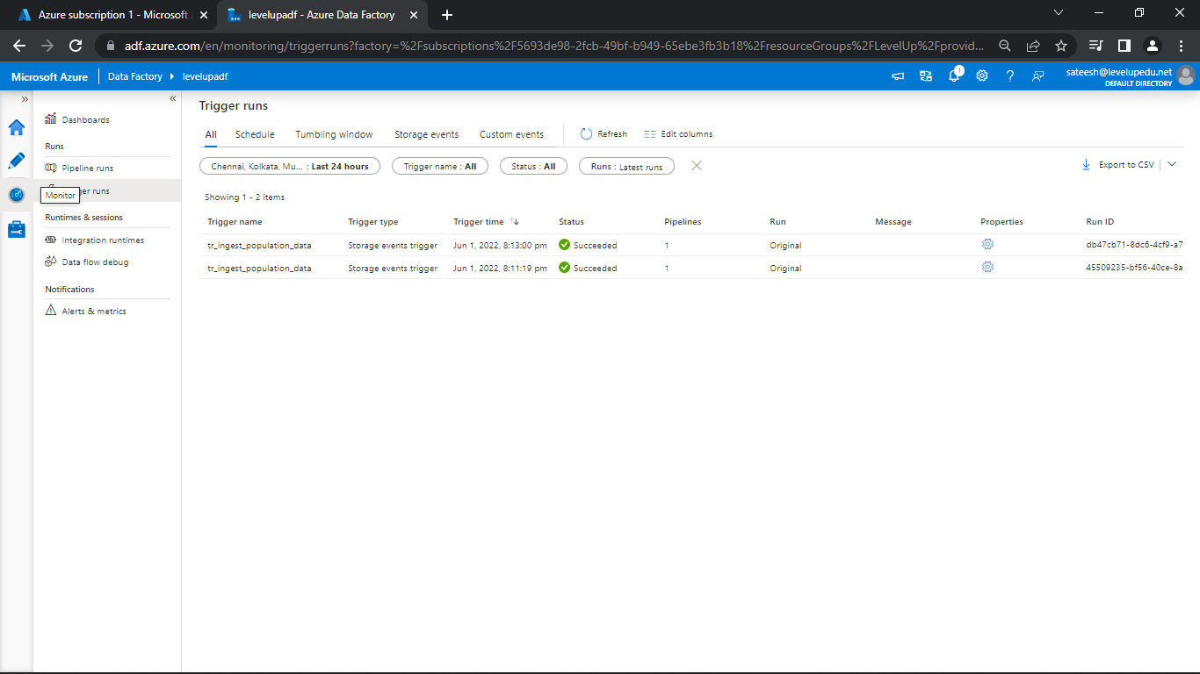

**Useful Links & Resources**

Section: Data Ingestion from Blob

Lecture: Copy Activity Introduction

<https://docs.microsoft.com/en-us/azure/data-factory/copy-activity-overview>

Lecture: Linked Services & Datasets

<https://docs.microsoft.com/en-us/azure/data-factory/concepts-linked-services>

<https://docs.microsoft.com/en-us/azure/data-factory/concepts-datasets-linked-services>

Lecture: Create Pipeline

<https://docs.microsoft.com/en-us/azure/data-factory/concepts-pipelines-activities>

Lecture: Control Flow Activities

Validation Activity - <https://docs.microsoft.com/en-us/azure/data-factory/control-flow-validation-activity>

Get Metadata Activity - <https://docs.microsoft.com/en-us/azure/data-factory/control-flow-get-metadata-activity>

If Condition Activity - <https://docs.microsoft.com/en-us/azure/data-factory/control-flow-if-condition-activity>

Web Activity - <https://docs.microsoft.com/en-us/azure/data-factory/control-flow-web-activity>

Delete Activity - <https://docs.microsoft.com/en-us/azure/data-factory/delete-activity>

Lecture: Triggers

<https://docs.microsoft.com/en-us/azure/data-factory/concepts-pipeline-execution-triggers>